Contents
05/09/2023 07:15 pm Sparrow Emergency Department Provider Note 3
05/09/2023 07:45 pm Brief Intervention Dr. Samat 5
05/09/2023 08:10 pm Neurosurgery Consultation Note 5
05/09/2023 07:03 pm Trauma History & Physical / Consult Note 8
05/10/2023 12:38 am Plan of Care by Ledya 13
05/10/2023 07:25 am Neurosurgery Daily Progress Notes 13
05/10/2023 09:53 am Physical Therapy Initial Evaluation 16
05/10/2023 11:39 am Occupational Therapy Initial Evaluation 18
05/10/2023 12:24 pm Trauma/Surgical Critical Care Progress Note 20
05/10/2023 04:39 pm SLP Speech Language Eval Note Audit by Clay B 23
05/10/2023 04:40 pm Speech Language Evaluation 24
05/10/2023 09:38 pm Plan of Care by Rebekah Geiger, RN 25
05/11/2023 02:53 am Nursing Note by Rebekah Geiger, RN 26
05/11/2023 03:16 am Significant Event by Rebekah Geiger, RN 26
05/11/2023 04:08 am Nursing Note by Rebekah Geiger, RN 26
05/11/2023 04:44 am Brief Intervention by Peter Collings, MD 26
05/11/2023 06:22 am Nursing Note by Rebekah Geiger, RN 27
05/11/2023 07:21 am Hospice Informed Consent by Michael Shafer, PhD 27
05/11/2023 07:27 am Neuropsych - Impressions by Michael Shafer, PhD 28
05/11/2023 07:29 am SMG Neuropsychology Consult 28
05/11/2023 01:12 pm Progress Notes by Dr. Ansari 30
05/11/2023 03:35 pm Sparrow Trauma Daily Progress Note 30
05/12/2023 07:21 am Sparrow Trauma Daily Progress Note 34
05/12/2023 09:10 pm Plan of Care by Torri K 37
05/12/2023 10:42 pm Nursing Note by Torri Kat 38
05/13/2023 08:36 am Therapy Note by Rhonda S 38
05/13/2023 12:16 am Sparrow Trauma Daily Progress Note 38
05/13/2023 02:48 pm Plan of Care by Kelcey Baker, RN 41
05/13/2023 11:30 pm Plan of Care by Claire E Scavarda, RN 43
05/14/2023 07:19 am Sparrow Trauma Daily Progress Note 44
05/14/2023 11:30 am PT Misc. Treatment Note 47
05/14/2023 02:25 pm Progress Notes by Bethanie L McCullough, NP 47
05/14/2023 03:09 pm Plan of Care by Kelcey B 48
05/14/2023 09:35 pm Plan of Care by Rebekah Geiger, RN 50
05/15/2023 08:13 am Consults by Kathleen N, RN 51
05/15/2023 09:36 am Plan of Care by Abigail Vat 51
05/15/2023 01:01 pm Sparrow Trauma Daily Progress Note 51
05/15/2023 08:23 pm Plan of Care by Rebekah Geiger, RN 54
05/16/2023 10:12 am Palliative Care / Hospice Consult Note 56
05/16/2023 11:10 am Sparrow Trauma Daily Progress Note Garrett D 60
05/16/2023 01:06 pm Hospice Informed Consent 63
05/16/2023 04:10 pm Progress Notes by Virginia 65
05/16/2023 09:22 pm Plan of Care by Alaina Q Miner, RN 65
05/17/2023 08:39 am Sparrow Trauma Daily Progress Note 67
05/17/2023 02:28 pm Palliative Care Progress Note 70
05/18/2023 08:37 am Trauma Services Discharge Summary 71
05/18/2023 09:45 am Patient Support Services Case Manager Discharge Note 74
05/18/2023 10:00 am Informed consent completed with Abigial in hospital Dr. Perry agrees to follow. 74

 | Timeline of Sparrow Hospital Events – Negligence, Misdiagnosis, Coding Errors, Medical documentation Errors. Wife Spreading False and Misleading Medical Information and no Past Medical History attempt to confirm by Sparrow Staff.
Start with Discharge Notes multiple errors. | #1 5/18/2023 From Dr. Erin Sarzynski – Sparrow HOSPICE Doctor - Hospice Intake Notes  List of  - Negligent Misdiagnosis by Michael Shafer PHD psychologist, Sparrow Hospital  - Medical Documentation Errors – “Copy/Paste” issues that were ruled out  - Medicare Up-coded “Tiny SAH” twice  - No “Medical History” of Dementia just a negligent Primary Care Physician taking wild guesses based of my father’s obsession with “Memory Loss”  - No orbit fracture - Again ruled out by CT Scan 5/13 yet “copy/pasted” into Discharge Notes  From Sparrow Hospital Record page #140  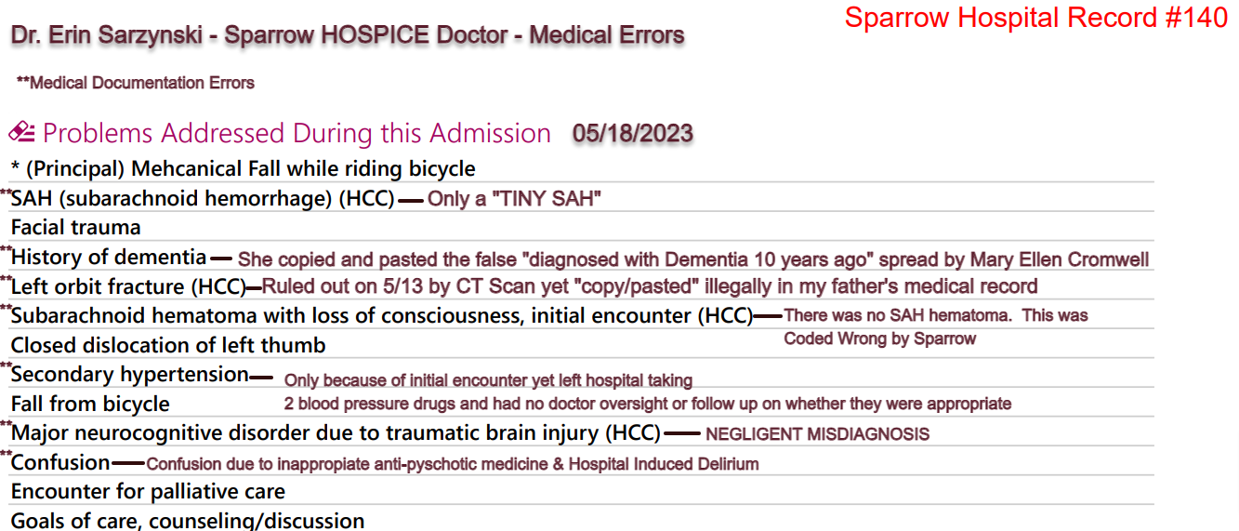  And  #2 05/18/2023 Sparrow Hospital Trauma Unit Discharge Notes  From Sparrow Hospital Record page #122  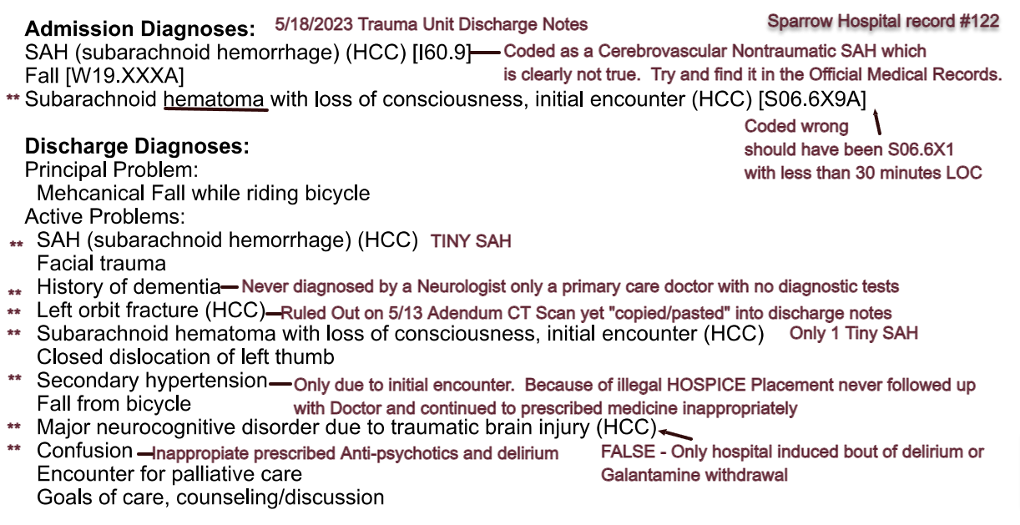  S06.6X9 Traumatic subarachnoid hemorrhage with loss of consciousness of unspecified duration  S06.6X1 Traumatic subarachnoid hemorrhage with loss of consciousness of 30 minutes or less  1st: I60 Diagnosis Code I60 Nontraumatic subarachnoid hemorrhage  2023 ICD-10-CM Diagnosis Code I60.9 Nontraumatic subarachnoid hemorrhage, unspecified
 | Start of timeline on 05/09/2023
5/9/2023  7:15 pm | 05/09/2023 07:15 pm Sparrow Emergency Department Provider Note  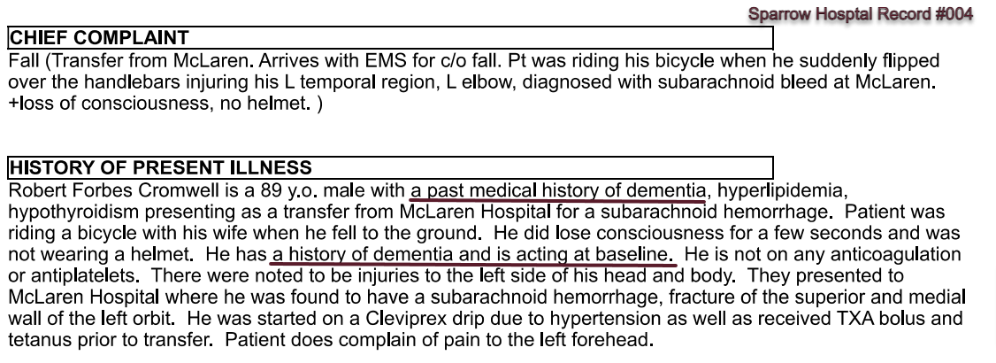  Bike crash was at approximately 4:00 pm on 5/9/2023  At 7:15 pm my father’s wife gives Past Medical History 1st to Sparrow emergency Department:  - Past medical history of dementia  (my father does not have a medical history of dementia, a 2020 attempt by Dr. Huffman a Neuropsychiatry and she was unsure and recommended ruling out all reversible causes)  - Hyperlipidemia  (my father has been on statins for close to 40 years and his pcp never bothered to test for my father’s baseline cholesterol level. He just continued the tradition)  - Hypothyroidism  (based on 3 TSH results in 2003 see here)
5/09/2023  7:45 pm | 05/09/2023 07:45 pm Brief Intervention Dr. Samat  “Know of left orbital wall fracture. No entrapment on physical exam currently. Will discuss reaching out to Dr. Novelli.”  RULED OUT ON 5/13 OFFICIALLY  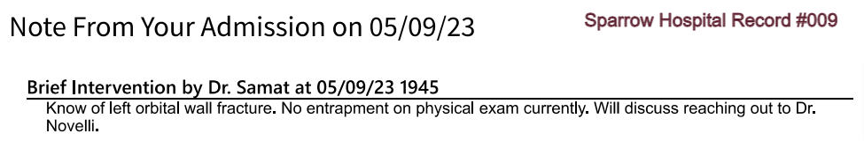  Medical Documentation Error  Per CT Scan Addendum on 5/13  - Possibly a nondisplaced fracture if any  - No Intraorbital Abnormality  This did not stop the Hospice Doctor from listing a full “Orbital Wall Fracture” as a reason for Hospice Placement (see here)  From Medical Record Page 163. 5/13 CT Scan Addendum  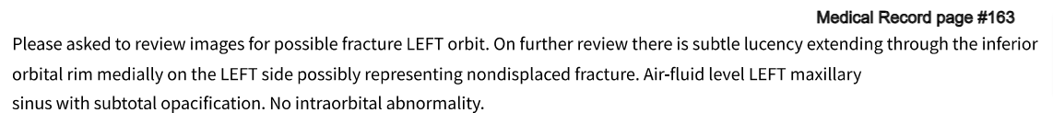
5/9/2023  8:10pm  Adrienne C Shane, PA-C | 05/09/2023 08:10 pm Neurosurgery Consultation Note  1. His wife is at bedside and states that he has dementia al baseline.  2. Tiny L SAH  3. Glasgow Coma Scale Score: 14 (only a mild TBI/Concussion) see here  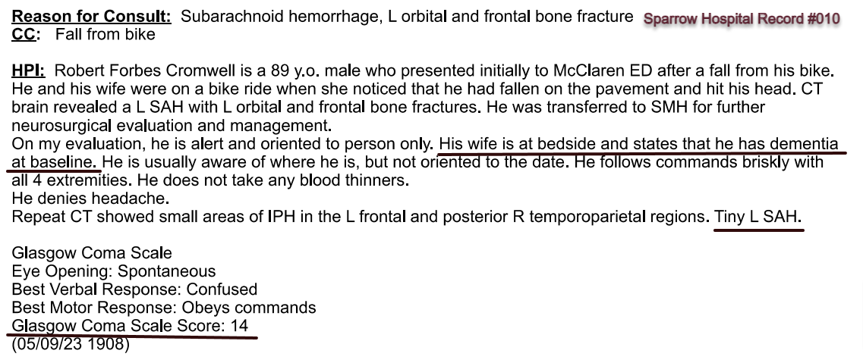  Per the American College of Surgeons “Best Practices in the Management of Traumatic Brain”  From Page 3 Using the Glasgow Coma Scale  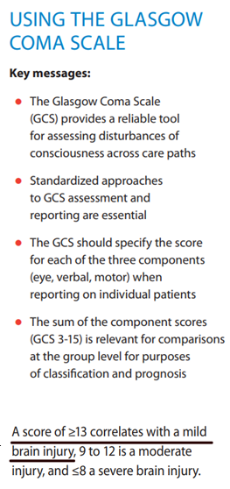  ASSESSMENT  Active Problems:  Mechanical Fall while riding bicycle  SAH (subarachnoid hemorrhage) (HCC)  Facial trauma  History of dementia  Left orbit fracture (HCC)  LSAH  IPH  Plan:  Repeat CT in am –  Neuro checks 01 H  Notify neurosurgery with any decline in exam  No blood thinners –  PAS for DVT prophylaxis  SBP <140  Head-of-bed>30 degrees  Further recommendations to follow neurosurgery team Rounds
05/09/2023  09:03 pm  Attending Trauma Surgeon Dr. Munoz  Leah Babiarz, DO | 05/09/2023 07:03 pm Trauma History & Physical / Consult Note  The patient is a 89 y.o. male with PMHx of dementia,  Per wife they were both riding their bicycles outside.  Shortly after patient was acting his baseline (note here that baseline on 5/9 during admittance was “riding his 2 wheel bike for 5 to 15 miles)  Hospital Medications:  MEDICATION DOSAGE TIMES A DAY TOTAL DAY  clevidipine 2 mg/hr 5/9/2023 2103  Electrolyte-A  Atorvastatin 40 mg Oral Daily  Levothyroxine 50 mcg Oral Daily  Cholecalciferol 1000 Units Oral Daily  Senna 17.2 Oral Nightly  Tiotropium 2 puff Inhalation Daily per RT  tranexamic acid 1000 mg Intravenous Once  acetaminophen, 650 mg Q6H PRN  ondansetron HCI, 4 mg Q8H PRN  ondansetron, 4 mg Q8H PRN  Active Problems:  Facial trauma Left orbit fracture (HCC)  Mechanical Fall while riding bicycle  SAH (subarachnoid hemorrhage) (HCC)  History of dementia  Closed dislocation of left thumb  Secondary hypertension  ASSESSMENT:  Level 1 Trauma s/p fall from bicycle.  PLAN:  Diagnostics, laboratory work, IVF, and pain control per protocol  Maintain c-spine precautions until cleared  NPO until cleared by trauma  No entrapment of the left eye. EOMI. Can f/u outpatient for orbital fracture  No blood thinners  Neuro checks  TXA bolus completed. TXA infusion  Repeat CT in am
5/10/2023  7:25am  Stephanie Brown, PA  Dr. Qahwash | 05/10/2023 07:25 am Neurosurgery Daily Progress Notes  Neurosurgery Unit determined early morning 5/10 he had a mildTBI and cleared him for discharge with no need for intervention.  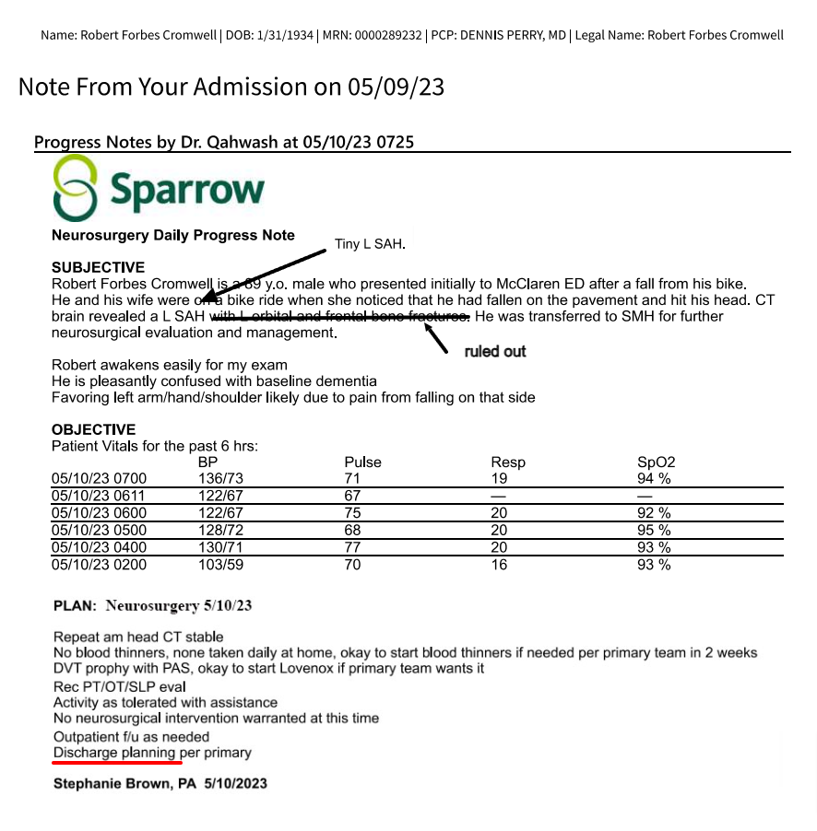  MEDICATION DOSAGE TIMES A DAY TOTAL DAY  Atorvastatin 40 mg Oral Daily  Levothyroxine 50 mcg Oral Daily  Cholecalciferol 1000 Units Oral Daily  Senna 17.2 Oral Nightly  tiotropium 2 puff Inhalation Daily per RT  tranexamic acid 1000 mg Intravenous Once  Continuous Infusions:  PRN Meds: hydralazine, acetaminophen, ondansetron HCL **OR** ondansetron  Comorbidities identified by EMR data:  Thrombocytopenia: The patient meets criteria for a diagnosis of thrombocytopenia based on a platelet level of 149 x 10"3/microliter or less, with evidence of monitoring (a subsequent platelet level during the same encounter).  ASSESSMENT:  Principal Problem:  Mechanical: Fall while riding bicycle  Active Problems:  - SAH (subarachnoid hemorrhage) (HCC)  - Facial trauma  - History of dementia  - Left orbit fracture (HCC)  - Subarachnoid hematoma with loss of consciousness, initial encounter (HCC)  - Closed dislocation of left thumb  - Secondary hypertension  PLAN:  Repeat am head CT stable  No blood thinners, none taken daily at home, okay to start blood thinners if needed per primary team in 2 weeks  DVT prophy with PAS, okay to start Lovenox if primary team wants it  Neuropsych eval recommended  Rec PT/OT/SLP eval  Activity as tolerated with assistance  No neurosurgical intervention warranted at this time  Continue neuromotor checks and contact our team if any changes  Outpatient f /u as needed  Discharge planning per primary
05/10/2023  9:53 am  Valerie Collins, PT | 05/10/2023 09:53 am Physical Therapy Initial Evaluation  Valerie Collins, PT  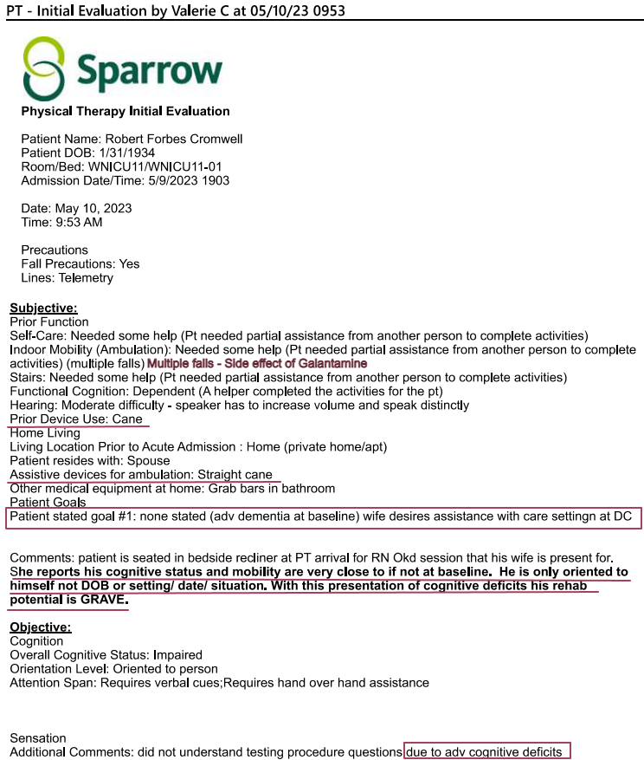  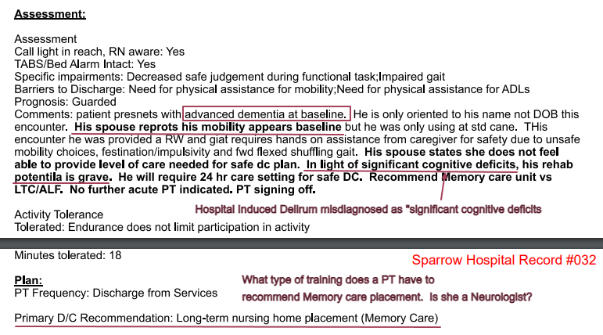  #1. Yesterday 5/9 my father’s wife at admission states he has “dementia” at baseline. Now today on 5/10 she changes it to “Advanced Dementia at Baseline.” Big difference.  #2. Why is a Physical Therapist evaluating my father for a memory unit while he is in the middle of a bout of hospital induced delirium. She misdiagnosed my father as “Grave” in rehab and because his wife once again spreading false and misleading medical data claiming he has “Advanced Dementia” at baseline. My father does not have Dementia or Alzheimer’s. His wife has been harming my father for years and the actions and events during this hospital stay prove how she tries to manipulate, change stories for some nefarious motive.  From the American College of Surgeon “Best Practices in the Management of Traumatic Brain Injury” Page 19 and 20  “It is extremely important for the patient that family and caregivers stay truthful and maintain consistency in describing. “  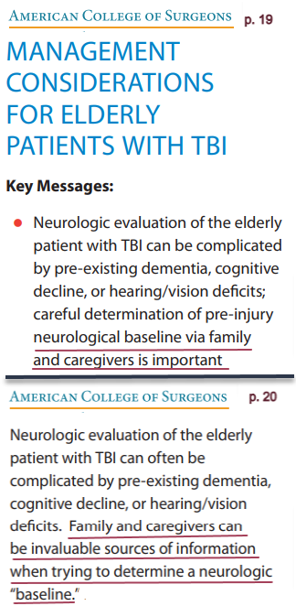
05/10/2023  11:39 am  Dawn M Doneth, OTR/L | 05/10/2023 11:39 am Occupational Therapy Initial Evaluation  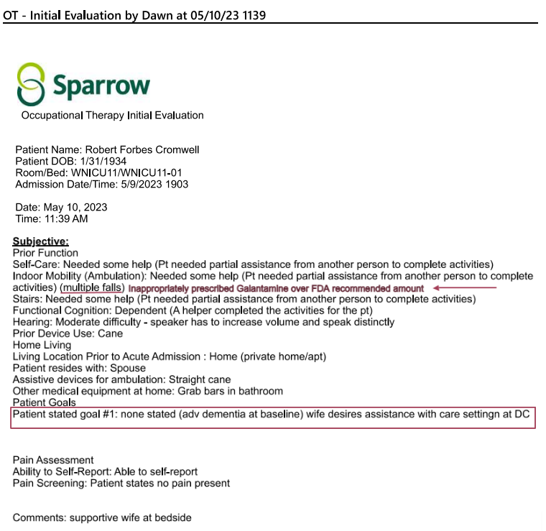  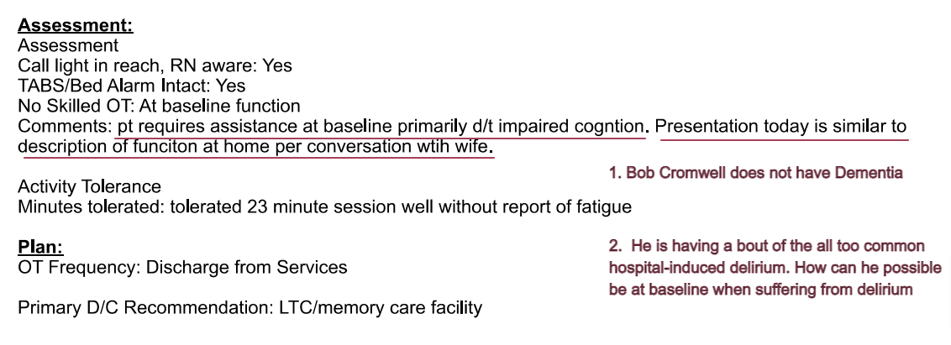  #1. My father’s wife changes baseline again. How can he be at baseline at home while suffering from a bout of hospital induced delirium once again negligently misdiagnosed as something else based on my father’s wife spreading multiple false and misleading medical information.  Why are decisions being made on rehab while?  My father is suffering from delirium.  Delirium that got misdiagnosed as  Major Neurocognitive Disorder probable  Alzheimer's. My father does not have Dementia.  or Alzheimer's.
05/10/2023  12:24 pm  Bethanie L McCullough, NP  Rounding Attending: Dr. Uitvlugt | 05/10/2023 12:24 pm Trauma/Surgical Critical Care Progress Note  Rounding Attending: Dr. Uitvlugt  INTERVAL HISTORY:  5/9: 89 yo male that fell off his mechanical bike while unhelmeted and struck his head. Found to have a SAH at OSH and transferred to Sparrow Main. Admitted to NTICU for close monitoring  SUBJECTIVE:  Patient up in chair, wife at bedside. Pleasant in conversation, but disoriented to place, time.  OBJECTIVE:  Vitals:  5/10/2023 BP-130/101 Pulse-75 Resp:-22 SpO2-95%  5/10/2023 BP-134/63 Pulse-89 Resp:-21 SpO2-93%  5/10/2023 BP-116/66 Pulse-85 Resp:-19 SpO2-95%  5/10/2023 BP-102/59 Pulse-71 Resp:-18 SpO2-93%  PHYSICAL EXAM:  Physical Exam  Vitals and nursing note reviewed.  HENT:  Head: Normocephalic. Contusion and left periorbital erythema present.  Comments: Abrasion to left scalp  Eyes:  Pupils: Pupils are equal, round, and reactive to light.  Cardiovascular:  Rate and Rhythm: Normal rate and regular rhythm.  Pulmonary:  Effort: Pulmonary effort is normal.  Breath sounds: Normal breath sounds.  Abdominal:  General: Bowel sounds are normal.  Palpations: Abdomen is soft.  Musculoskeletal:  General: Normal range of motion.  Cervical back: Normal, normal range of motion and neck supple. No bony tenderness.  Thoracic back: Normal. No bony tenderness.  Lumbar back: Normal. No bony tenderness.  Skin:  General: Skin is warm and dry.  Findings: Abrasion present.  Comments: Abrasion to left elbow and left hand  Neurological:  Mental Status: He is alert. Mental status is at baseline.  GCS: GCS eye subscore is 4. GCS verbal subscore is 4. GCS motor subscore is 6.  Lab 05/09/2023 1910 05/10/2023 0359  WBC 12.6 7.7  HGB 15.6 14.4  HCT 47.4 42.6  PLT 113 116 (L)  MCV 86  Lab 05/09/2023 05/10/2023  NA 140 138  K 3.8 3.9  CL 103 104  CO2 25.0 25.0  BUN 14 10  Creatinine .76 .70  Glucose 113 102  Lactate: Value-.9 ref range .2-1.8 mmol/L  RADIOLOGY:  See* Order: CT Brain/Head wo Contrast Result Date: 5/10/2023  See* Order: CT Brain/Head wo Contrast Result Date: 5/9/2023  See* Order: CT Maxillofacial wo Contrast Result Date: 5/9/2023  See* Order: CT Angiogram Head & Neck w Contrast Result Date: 5/9/2023  Comorbidities identified by EMR data:  Thrombocytopenia:  The patient meets criteria for a diagnosis of thrombocytopenia based on a platelet level of  149 x 10 OA3/microliter or less, with evidence of monitoring (a subsequent platelet level during the same encounter).  ASSESSMENT:  Robert Forbes Cromwell is 89 y.o. male. Hospital Day: 2.  Principal Problem:  Mechanical Fall while riding bicycle  Active Problems:  SAH (subarachnoid hemorrhage) (HCC)  Facial trauma  History of dementia  Left orbit fracture (HCC)  Subarachnoid hematoma with loss of consciousness, initial encounter (HCC)  Closed dislocation of left thumb  Secondary hypertension  PLAN:  NEURO:  SAH  • Neurosurgery  o Hold thinners  o Goal SBP < 140  o Repeat head stable  Hx(history): dementia:  • Neuropsychology consult - per discussion with Dr Shafer, patient does not have capacity, wife brought in DPOA paperwork  • Will need second physician to write statement in agreement to activate DPOA  Hx(history): anxiety  • Restart home lexapro 10 mg nightly  CV: HTN (hypertension)  • Add amlodipine 5 mg daily to achieve goal SBP < 140  • Sinus rhythm  • Continue to monitor telemetry  RESP:  On RA  RENAL:  Voiding  1100 ml overnight  Creatinine: 0.7  FENGI: (Fluids, Electrolytes, Nutrition, gastrointestinal)  Fluids:None  Diet: General  Following critical care electrolyte protocol  Bowel regimen: Miralax daily  Last bowel movement: PTA  ID:  Afebrile, no leukocytosis  qSOFA: Quick Sepsis related Organ Failure Assessment  GCS≤13: 0  RR≥ 22: 0  BP systolic ≤ 100: 0  Total score: 0  ENDOCRINE:  Glucose stable 102  Hx: hypothyroidism  Restart home med levothyroxine  HEME:  Hgb 14.4  • Stable, continue to monitor  MSK/Skin: Left orbital wall fracture  • Seen on review of imaging, will ask for addended read  • Likely non-operative, will plan to have Dr Novelli assess tomorrow when he is on call  TUBES/LINES/DRAINS:  PIV  DVT prophylaxis: PAS only  PT/OT: L TC/Memory Care  SLP/Dysphagia: Pending evaluation  CODE STATUS: DNR - discussed code status with patient and wife/dpoa who are in agreement that patient would like to be DNR/DNI  Bethanie L McCullough, NP  5/10/2023 12:28 PM  Trauma/Critical Care Resident Phone: 253-2331  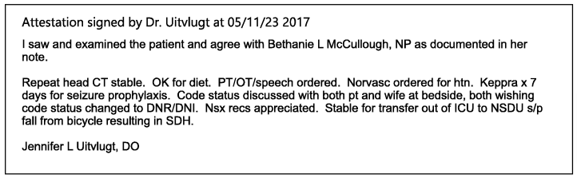
05/10/2023  4:39 pm | 05/10/2023 04:39 pm SLP Speech Language Eval Note Audit by Clay B  Mr. Cromwell seen for cognitive-linguistic evaluation. Pt presents w/ word-finding difficulties, very poor sustained attention and nearly absent divided attention, impaired delayed recall at -1 minute, temporal disorientation, significantly impaired sequencing and simple problem-solving. He is oriented to self and situation and "medical facility" as location. Discussed in detail w/ wife pt's cognitive-linguistic baseline PtA. He is reported to exhibit deficits observed during this evaluation at baseline. Wife in agreement that given his poor recall and reduced receptive ability, he is unlikely to benefit from cognitive-linguistic therapeutic intervention in the acute phase. Will sign off. RN aware.
05/10/2023  4:40 pm  Clay Boersma, MS,CCC-SLP/L | 05/10/2023 04:40 pm Speech Language Evaluation  Background Information  Robert Forbes Cromwell is a 89 y.o. male, who was admitted to Sparrow Health System secondary to The encounter diagnosis was SAH (Subarachnoid hemorrhage) (HCC)  Past Medical History see above*  Subjective:  Pain Assessment  Ability to Self-Report: Able to self-report  Pain Screening: Patient states no pain present  Prior Function  IADLS: Med Management  IADL Comments: Per wife med management w intermittent supervision  Employment Status: Retired  Comments: Retired civil engineer for state of MI  Hearing: Hard of Hearing despite device  Patient stated goal#1: None stated  Comment: Pt alert and cooperative. No visitor present for evaluation. Spoke with wife regarding baseline before evaluation  Objective:  Orientation: Person; Situation  Orientation Comment: Stated "a medical facility" for location, disoriented to all elements of time. Oriented to bicycle fall without helmet as situation.  Behavior/Cognition: Alert; Cooperative; Reduced insight  Pragmatics: Cooperative and pleasant  Auditory Comprehension  Simple Yes/No (% correct): 100  1 Step Commands (% correct): 100  Verbal Expression  Sentence Repetition (% correct): 0 %  Verbal Expression Comment: Occasional phonetic paraphasia. Wife reports semantic paraphasias observed at baseline.  Automatics Days (% correct): 100  Episodic Memory  Delayed Recall (% ): 0 %  Episodic Memory Comment: 0/4 for pt recalling the question he was attempting to answer  Intelligibility/Voice  Intelligibility: Intelligible  Clock Drawing Clock Drawing Severity Range: Severe (Missing many numbers and hour and minute hand set incorrectly with no self-correction)  Summary and Impression:  Mr. Cromwell seen for cognitive-linguistic evaluation. Pt presents w/ word-finding difficulties, very poor sustained attention and nearly absent divided attention, impaired delayed recall at -1 minute, temporal disorientation, significantly impaired sequencing and simple problem-solving. He is oriented to self and situation and "medical facility" as location. Discussed in detail w/ wife pt's cognitive-linguistic baseline PtA. He is reported to exhibit deficits observed during this evaluation at baseline. Wife in agreement that given his poor recall and reduced receptive ability, he is unlikely to benefit from cognitive-linguistic therapeutic intervention in the acute phase. Will sign off. RN aware.  Assessment:  Call light in reach, RN aware: Yes  TABS/Bed Alarm Intact: Yes  Speech Therapy Prognosis  Prognosis: Guarded  Prognosis Considerations: Co-Morbidities; Severity of Impairments  Tolerance  Patient Tolerance for Therapy Session: Adequate level of alertness; Decreased attention  Plan: Cognition Frequency: Cognition Discharge from Services  SLP Discharge Recommendations: Home with 24 hour supervision/assist, Long-term nursing home placement  Charges SLP Time Duration SLP Start Time: 1540 SLP Stop Time: 1610 SLP Total Time: 30 Minutes SLP Evaluations $$ Eval of Language Comprehension/Expression (92523): 1 Procedure  Clay Boersma, MS,CCC-SLP/L  May 10, 2023 4:40 PM
05/10/23 9:38 pm  Rebekah Geiger, RN | 05/10/2023 09:38 pm Plan of Care by Rebekah Geiger, RN  Rebekah Geiger, RN  Problem: Fall Prevention  Goal: Identify risk factors for falls  Description: Identify risk factors for falls on admission and every shift and as needed  Outcome: Ongoing  Goal: Ability to state ways to decrease risk of falls supported  Description: Ability to state ways to decrease risk of falls will be supported  Outcome: Ongoing  Goal: Implement fall bundle protocol  Outcome: Ongoing  Problem: General and/or Acute Pain  Goal: Pain will be safely and adequately managed throughout hospitalization  Description: Please see associated flowsheet rows for the assessment.  Outcome: Ongoing Flowsheets (Taken 5/10/2023 2050)  Ability to Self-Report Able to self-report  Problem: Stroke Education  Goal: Knowledge of disease will improve prior to discharge  Outcome: Ongoing  Goal: Ability to identify and develop coping behaviors will improve prior to discharge  Outcome: Ongoing  Goal: Knowledge of diagnosis risk factors will improve prior to discharge  Outcome: Ongoing  Problem: Tissue Perfusion  Goal: Ability to maintain intracranial pressure will stabilize during hospitalization  Outcome: Ongoing  Problem: Activity Intolerance/Impaired Mobility  Goal: Patient will return to baseline or improved mobility by discharge  Outcome: Ongoing  Problem: Safety  Goal: Ability to remain free from injury will be supported throughout hospitalization  Outcome: Ongoing  Problem: Acute Confusion  Goal: Patient will return to baseline mentation prior to discharge  Outcome: Ongoing  Problem: Risk for healthcare acquired conditions  Goal: Minimize the risk for acquiring healthcare acquired conditions throughout hospitalization Outcome: Ongoing  Note: This care plan reflects last filed documentation at the time of this note. For further review of documentation, see associated flowsheet rows.  Intervention: Hospital Acquired Pneumonia Interventions  Recent Flowsheet Documentation  Taken 5/10/2023 2050 by Rebekah Geiger, RN  Head of Bed Elevated: HOB 30  Intervention: Skin Interventions  Recent Flowsheet Documentation  Taken 5/10/2023 2050 by Rebekah Geiger, RN  Medical Device Off Loaded: Telemetry/Oximetry wires  Repositioning Interventions: Turns self  Head of Bed Elevated: HOB 30  Sleep Surface: Pressure redistribution mattress  Patient Position: Semi-Fowlers
05/11/23 2:53 am  Rebekah Geiger, RN | 05/11/2023 02:53 am Nursing Note by Rebekah Geiger, RN  Patient making frequent attempts to get out of bed, setting bed alarm off. Patient oriented to self only. Patient redirectable back to bed or to bathroom (when needed) but persistently attempting to get out of bed despite redirection.
05/11/2023  3:16 am  Rebekah Geiger, RN | 05/11/2023 03:16 am Significant Event by Rebekah Geiger, RN  Patient restless, frequently attempting to get out of bed and unsteady. Safety attendant now at bedside. MD paged for BP medication.  181/87
05/11/2023  4:08 am  Rebekah Geiger, RN | 05/11/2023 04:08 am Nursing Note by Rebekah Geiger, RN  Patient becoming paranoid (first saying we took his daughter, then his wife). Initially not allowing RN to give BP medication. Frequent attempts at reorienting without success. Patient not redirectable by safety attendant or RN. Patient out of bed in hallway, unsteady, refusing to go back in room and shouting for the police. Charge RN called code BERT. Patient grabbed RN's hand but did release it when she said ouch. Security assisted patient back to room, where he sat on the edge of the bed.
05/11/2023  4:44 am  Peter A. Collings, MD | 05/11/2023 04:44 am Brief Intervention by Peter Collings, MD  Paged by RN regarding patient becoming increasingly agitated. Per RN, patient was hallucinating and was increasingly paranoid. He was becoming both verbally and physically aggressive towards staff. Patient seen and examined at bedside. He is not oriented to person, place, or time. Significant expressive aphasia noted. No other focal neurologic deficits appreciated on examination. Given no documentation of previous expressive aphasia, concern at this time is for worsening hemorrhage. This may be due to delirium versus dementia, however cannot exclude an acute intracranial process.  -CT head stat  -Zyprexa IM for agitation  0500: patient physically aggressive toward staff. Attempted to punch and kick RNs multiple times. Ultimately the decision was made to place 4-point soft restraints in order to protect patient and staff well-being.  Peter A. Collings, MD  General Surgery Resident,  PGY-1 Pager: 226-3340
05/11/2023  6:22 am  Rebekah Geiger, RN | 05/11/2023 06:22 am Nursing Note by Rebekah Geiger, RN  Patient continues to be restless. Safety attendant at bedside. Patient declined offered beverages. RN attempted called spouse with an update and left a voicemail to return the call.
05/11/2023  7:21 am  Michael Shafer, PhD | 05/11/2023 07:21 am Hospice Informed Consent by Michael Shafer, PhD  Active Ambulatory Problems  Diagnosis  • Osteoarthritis of right knee 08/17/2021  Resolved Ambulatory Problems  Diagnosis:  No Resolved Ambulatory Problems  Past Medical History:  Diagnosis  - Arthritis  - Cancer (HCC)  - Dementia  - Hearing loss  - Hyperlipidemia  - Inguinal hernia  - Murmur  - Thyroid disease  (Actual Screenshot of individual medical record with no explanation why Prostrate was left out of cancer.) Very Suspect for Hospice Fraud  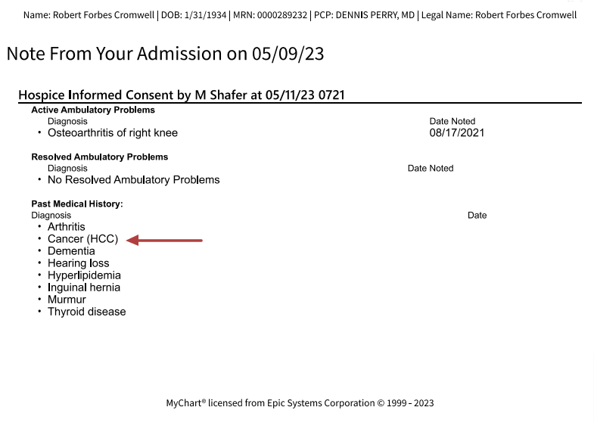
05/11/2023  7:27 am  Michael Shafer, PhD | 05/11/2023 07:27 am Neuropsych - Impressions by Michael Shafer, PhD  The patient was evaluated in the morning with family (wife) present. The patient was observed sitting up in a chair. Throughout the evaluation the patient exhibited a consistent propensity for confusion marked by poor memory capacity, impaired speech/language, and impaired executive functioning, including awareness and insight. According to family, the patient has been diagnosed with Alzheimer's Disease (advanced), which has become exacerbated by acute head injury. At this time, due to an aggregate of processes the patient does not demonstrate the capacity to make informed medical decisions. He will require assistance from his DPOA.
05/11/2023  7:29 am  Michael Shafer, PhD | 05/11/2023 07:29 am SMG Neuropsychology Consult  Michael Shafer, PhD  Recommendations:  Capacity and Decision Making  The patient does not demonstrate the cognitive capacity to make informed medical decisions (The patient has a DPOA)  TBI Management  NA  TBI Management – Return to Physical Activity/Exercise Sport  TBI Management – Return to School  NA  Additional Recommendations  SMG Neuropsychology will continue to follow the patient while they remain in the hospital  Psychiatric Recommendations  Defer opinion  Functional Neurological Disorder (FND)  NA  Psychological Functioning  NA  Impressions: The patient was evaluated in the morning with family (wife) present. The patient was observed sitting up in a chair. Throughout the evaluation the patient exhibited a consistent propensity for confusion marked by poor memory capacity, impaired speech/language, and impaired executive functioning, including awareness and insight. According to family, the patient has been diagnosed with Alzheimer's Disease (advanced), which has become exacerbated by acute head injury. At this time, due to an aggregate of processes the patient does not demonstrate the capacity to make informed medical decisions. He will require assistance from his DPOA.  Diagnostic Impressions:  1: mild complicated Traumatic Brain Injury (mTBI)  2: Major Neurocognitive Disorder (NCO) due to probable Alzheimer's Disease  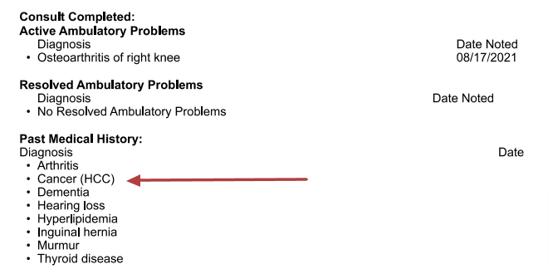  The patient has a positive medical history for the following: Past Medical History:  Past Medical History:  Diagnosis  • Arthritis osteoarthritis in both hands  • Cancer (HCC) prostate  • Dementia  • Hearing loss aids in both ears  • Hyperlipidemia  • Inguinal hernia  • Murmur  • Thyroid disease  Past Surgical History: see above*  Objective:  General Information  Consulting Psychologist: Michael Shafer, PhD  Reason for Consult:  - Concussion,  - Suspected dementia,  - Decision making capacity,  - Need for 24/7 supervision.  Mental Status Evaluation  Appearance: Congruent with medical condition  Behavior: Cooperative, Disinhibited  Speech: Clear, Poverty of speech, Poverty of content Mood: Anxious, Labile  Affect: Mood-congruent  Thought Process: Slowed, Tangential, Rambling  Thought Content: Unable to assess  Attention: Fluctuating  Concentration: Decreased  Intelligence: Estimated average  Knowledge: Poor  Memory Immediate: Poor  Memory Remote: Poor  Orientation: Alert  Cognition: Impaired, Impaired due to Alzheimer’s  Insight: Limited  Judgment: Limited  Screenshot of “Imaging:” actual inputs into the Neuropsychology Consult  Dr. Shafer and Dr. Sarzynski (hospice Dr.) are the only 2 doctors who left out the full results of the SAH CT Findings/Dementia literally ruling out Neurodegenerative disease including Alzheimer’s and Dementia.  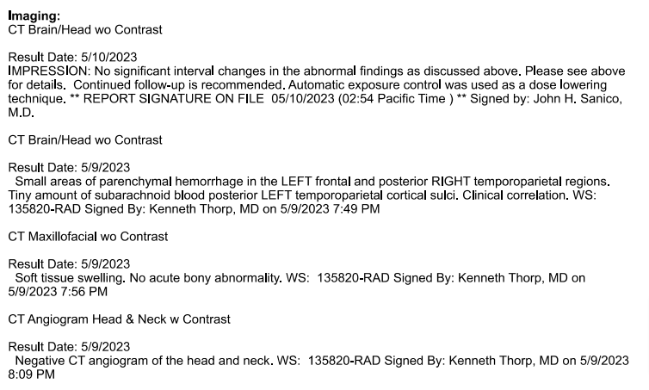  Physical Therapy:  Occupational Therapy:  Speech Therapy:  Speech Summary and Impression: No notes on file  Dysphagia Summary and impression: No notes on file  Time Spent  Time Spent: 96116 (NBSE) (55 min)  Michael Shafer, PhD  5/11/2023  7:29AM
05/11/2023  1:12 pm  Dr. Ansari | 05/11/2023 01:12 pm Progress Notes by Dr. Ansari  I believe that the patient does not have cognitive mental capacity to make his own informed medical decisions. Per his wife, the patient has had advancing Alzheimer's dementia for multiple years. He has had a significant subarachnoid hemorrhage related to his recent bike riding accident. He has had a concussion related to this. Last night he required multiple doses of Zyprexa to help with his agitated state. Today he is more somnolent, however is requiring soft restraints and a one-to-one sitter. The patient has a wife who states she is willing to be his DPOA and provide paperwork. I believe her acting as his DPOA is most appropriate.
05/11/2023  3:35 pm  Garrett D Smigelski, PA-C  Attestation:  Dr. Ansari | 05/11/2023 03:35 pm Sparrow Trauma Daily Progress Note  Progress Notes by G Smigelski  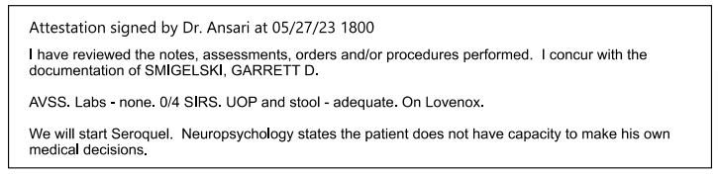  Problem List:  Principal Problem:  Mehcanical Fall while riding bicycle  Active Problems:  SAH (subarachnoid hemorrhage) (HCC)  Facial trauma  History of dementia  Left orbit fracture (HCC)  Subarachnoid hematoma with loss of consciousness, initial encounter (HCC)  Closed dislocation of left thumb  Secondary hypertension  Fall from bicycle  Major neurocognitive disorder due to traumatic brain injury (HCC)  Confusion  Interval History:  Pt seen in AM and again in afternoon, wife at bedside both times. Received Zyprexa x agitation overnight, now comfortably sleeping, will trial out of restraints today and start Seroquel.  Focused Physical Exam:  Vitals (Range for last 24 hrs):  Temp: [97.7 °F (36.5 °C)-98 °F (36.7 °C)] 97.7 °F  (36.5 °C)  Pulse: [69-109] 89  Resp: [12-27] 22  BP: (121-181)/(68-98) 121/69  Physical Exam  Constitutional:  General: He is not in acute distress.  Appearance: Normal appearance. He is normal weight. He is not ill-appearing or toxic-appearing.  Comments: Pleasant pt laying in bed  HENT:  Head: Normocephalic and atraumatic. (normal head) (minimal tissue injury)  Right Ear: External ear normal.  Left Ear: External ear normal.  Nose: Nose normal.  Mouth/Throat: Mouth: Mucous membranes are moist.  Pharynx: Oropharynx is clear.  Eyes:  Extraocular Movements: Extraocular movements intact.  Pupils: Pupils are equal, round, and reactive to light.  Cardiovascular:  Rate and Rhythm: Normal rate and regular rhythm.  Pulses: Normal pulses.  Heart sounds: Normal heart sounds. No murmur heard.  Pulmonary:  Effort: Pulmonary effort is normal. No respiratory distress.  Breath sounds: Normal breath sounds.  Abdominal:  Palpations: Abdomen is soft.  Tenderness: There is no abdominal tenderness.  Musculoskeletal:  General: Normal range of motion.  Skin:  General: Skin is warm and dry.  Capillary Refill: Capillary refill takes less than 2 seconds.  Neurological:  General: No focal deficit present.  Mental Status: He is alert. Mental status is at baseline.  GCS: GCS eye subscore is 3. GCS verbal subscore is 3. GCS motor subscore is 6.  Psychiatric:  Mood and Affect: Mood normal.  Behavior: Behavior normal.  MEDICATION DOSAGE  QUEtiapine 12.5 mg Oral Nightly schizophrenia, acute manic episodes  hydrALAZINE Continuous Infusions PRN direct vasodilator used orally to treat essential hypertension  ondansetron HCI **OR** ondansetron Continuous Infusions PRN Antiemetic It can prevent nausea and vomiting  acetaminophen, Continuous Infusions PRN  enoxaparin (LOVENOX) injection 40 mg Subcutaneous Daily prevent blood clots in the leg DVT prophylaxis  escitalopram 10 mg Oral Nightly (SSRI) approved for the acute and maintenance treatment of major depressive disorder  levETI RAcetam 500 mg Oral BID Seizures  Tiotropium (SPIRIVA RESPIMAT) 2 puff Inhalation Daily per RT bronchodilators Long-acting muscarinic antagonist medication (COPD)  cholecalciferol 1,000 Units Oral Daily vitamin D3  polyethylene glycol laxative 17 g Oral Daily laxative  Senna 17.2 Oral Nightly stimulant laxatives  amLODIPine 5 mg Oral Daily Calcium channel blocker  Atorvastatin 40 mg Oral Daily Lipitor, cholesterol  Levothyroxine 50 mcg Oral Daily thyroid  Comorbidities identified by EMR data:  Thrombocytopenia: The patient meets criteria for a diagnosis of thrombocytopenia based on a platelet level of 149 x 10∧3/microliter or less, with evidence of monitoring (a subsequent platelet level during the same encounter).  Assessment/Plan:  Benzodiazepines: no  IV opiates: no  -overnight pt had agitation that required restraints, Zyprexa IM x2. Since early AM behavior has improved  -start seroquel (Quetiapine) and trial out of restraints  Neuropsych:  The patient does not demonstrate the cognitive capacity to make informed medical decisions (The patient has a DPOA)  L orbital fx (left orbital fracture)  -consult plastics, Novelli, page sent and on treatment team.  -await formal recs (recommendations)  -DPOA activated today 5/11  -of note repeat CT head was ordered at time of agitation was noted "Significant expressive aphasia noted. No other focal neurologic deficits appreciated on examination. Given no documentation of previous expressive aphasia, concern at this time is for worsening hemorrhage."  --after further review pt has expressive aphasia at baseline per SLP note 5/10 "Occasional phonetic paraphasia. Wife reports semantic paraphasias observed at baseline."  verified w/ wife at bedside pt does have baseline aphasia, d/w day team trauma colleague that aphasia is baseline as well.  Discontinued CT head ordered overnight given baseline aphasia, with current recent behavior unlikely to complete CT at this time.  Repeat CT head already 5/10 w/ no significant interval changes from CT head 5/9 and reviewed per neuroSx team. –  will continue to monitor and if any change from baseline consider repeat CT  SBP > 150 or r <90: yes HTN in AM during times of agitation s/p norvasc and improved behavior BP 121/69.  Continue norvasc and continue to monitor. (NORVASC tablets are a prescription medicine to treat high blood pressure)  Lactate >2.0: no  Supplemental oxygen: no. Encourage IS ( Incentive spirometry)  Electrolytes abnormal (NA+, K+, C02-): no monitor w/ AM labs  IV fluids: yes Maintenance fluids given poor PO intake today  Oral nutrition: yes  Last bowel movement: 5/10; Smoothlax and Pericolace daily.  Urine output< 720 ml/24 h: yes  Foley: no.  Renal fxn at baseline w/ 5/9 labs. Monitor w/ AM labs  qSOFA:  GCS ≤ 13: yes  RR≥ 22: no  BP systolic ≤ 100: no  Total score: 1  Antibiotics: n/a  DVT prophylaxis: lovenox  Last dose: 5/11  PT/OT: LTC  Estimated discharge date and location; 5/16 LTC, pending behavior  Garrett D Smigelski, PA-C  5/11 /2023, 3:35 PM  Trauma Team Pager: 226-3350  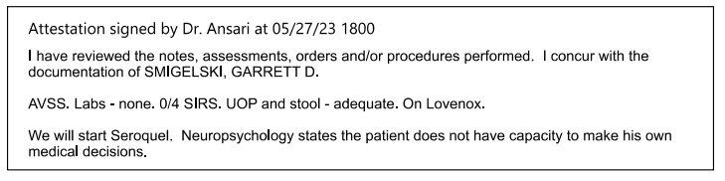  AVSS Afebrile, Vital Signs Stable · / SIRS Systemic inflammatory response syndrome / Urinary output
05/12/2023  7:21 am  Natalie M Fox, PA-C  Attestation:  Dr. Munoz  NAD (no abnormality detected)  Assessment: SAH  Plan: Placement Pending | 05/12/2023 07:21 am Sparrow Trauma Daily Progress Note  Natalie M Fox, PA-C  Problem List:  Principal Problem:  Mehcanical Fall while riding bicycle  Active Problems:  SAH (subarachnoid hemorrhage) (HCC)  Facial trauma  History of dementia  Left orbit fracture (HCC)  Subarachnoid hematoma with loss of consciousness, initial encounter (HCC)  Closed dislocation of left thumb  Secondary hypertension  Fall from bicycle  Major neurocognitive disorder due to traumatic brain injury (HCC)  Confusion  Interval History:  No acute events overnight. No further reports of agitation or aggression. Will trial off of sitter.  Family is hoping for subacute rehabilitation facility, will have PT/OT re-evaluate.  Focused Physical Exam:  Vitals (Range for Last 24 hrs):  Temp: [97 °F (36.1 °C)-97.7 °F (36.5 °C)] 97.7 °F  (36.5 °C)  Pulse: [70-108] 108  Resp: [16-20] 18  BP: (110-157)/(69-99) 120/69  Physical Exam  Constitutional:  Appearance: Normal appearance.  Comments: Resting comfortably in bed in no acute distress Son is present at bedside  HENT:  Head: Normocephalic. (normal head)  Comments: Left periorbital ecchymosis Abrasions and ecchymosis to left scalp  Mouth/Throat: Mouth: Mucous membranes are moist.  Pharynx: Oropharynx is clear.  Eyes:  Extraocular Movements: Extraocular movements intact.  Pupils: Pupils are equal, round, and reactive to light.  Cardiovascular:  Rate and Rhythm: Normal rate and regular rhythm.  Pulses:  Radial pulses are 2+ on the right side and 2+ on the left side.  Dorsalis pedis pulses are 2+ on the right side and 2+ on the left side.  Heart sounds: Murmur heard.  Systolic murmur is present  Pulmonary:  Effort: Pulmonary effort is normal. No respiratory distress.  Breath sounds: Normal breath sounds.  Comments: On room air (why was this bolded? Of course he is not that sick)  Abdominal:  General: Abdomen is flat.  Palpations: Abdomen is soft.  Tenderness: There is no abdominal tenderness.  Musculoskeletal:  General: Normal range of motion.  Cervical back: Normal range of motion and neck supple. No tenderness.  Neurological:  General: No focal deficit present.  Mental Status: He is alert. He is confused.  GCS: GCS eye subscore is 3. GCS verbal subscore is 3. GCS motor subscore is 6.  Sensory: Sensation is intact.  Motor: Motor function is intact  Psychiatric:  Mood and Affect: Mood normal.  Behavior: Behavior normal.  Scheduled Meds:  QUEtiapine 12.5 mg Oral Nightly schizophrenia, acute manic episodes  hydrALAZINE Continuous Infusions PRN direct vasodilator used orally to treat essential hypertension  ondansetron HCI **OR** ondansetron Continuous Infusions PRN Antiemetic It can prevent nausea and vomiting  acetaminophen, Continuous Infusions PRN  enoxaparin (LOVENOX) injection 40 mg Subcutaneous Daily prevent blood clots in the leg DVT prophylaxis  escitalopram 10 mg Oral Nightly (SSRI) approved for the acute and maintenance treatment of major depressive disorder  levETI RAcetam 500 mg Oral BID Seizures  Tiotropium (SPIRIVA RESPIMAT) 2 puff Inhalation Daily per RT bronchodilators Long-acting muscarinic antagonist medication (COPD)  cholecalciferol 1,000 Units Oral Daily vitamin D3  polyethylene glycol laxative 17 g Oral Daily laxative  Senna 17.2 Oral Nightly stimulant laxatives  amLODIPine 5 mg Oral Daily Calcium channel blocker  Atorvastatin 40 mg Oral Daily Lipitor, cholesterol  Levothyroxine 50 mcg Oral Daily thyroid  Comorbidities identified by EMR data:  Thrombocytopenia: The patient meets criteria for a diagnosis of thrombocytopenia based on a platelet level of 149 x 10∧3/microliter or less, with evidence of monitoring (a subsequent platelet level during the same encounter).  Assessment/Plan:  Benzodiazepines: no  IV opiates: no  SAH  • Neurosurgery  o Repeat head stable  o OK to start Lovenox for DVT ppx, though no blood thinners for 2 weeks  o Outpatient follow-up as needed  Dementia with behavioral disturbance  - Neuropsychology  o Does not demonstrate the cognitive capacity to make informed medical decisions (Patient's wife, Mary Ellen, activated DPOA)  - • Trial Seroquel (QUEtiapine)  SBP > 150 or <90 yes intermittently hypertensive, will increase amlodipine to 10 mg daily 5/13  Lactate >2.0: no  Supplemental oxygen: no. Encourage IS.  Electrolytes abnormal (NA+, K+, C02-): no  IV fluids: no  Oral nutrition: yes, House  Last bowel movement: 5/1 O;  Smoothlax and Pericolace daily.  Urine output< 720 ml/24 h: no  Foley: no.  qSOFA:  GCS ≤ 13: no  RR≥ 22: no  BP systolic ≤ 100: no  Total score: 0  Antibiotics: none  DVT prophylaxis: Lovenox 40 mg daily  Last dose: 5/11  Left orbital wall fracture  • Dr. Novelli consult 5/11, appreciate recommendations  PT/OT: LTC/memory care facility.  As patient with stable behaviors over past 24/hr, will ask for repeat PT/OT evaluations.  Estimated discharge date and location; Medically stable for placement, appreciate repeat therapy evaluations and CM assistance.  Natalie M Fox, PA-C  5/12/2023, 7:04 PM  Trauma Team Pager: 226-3350  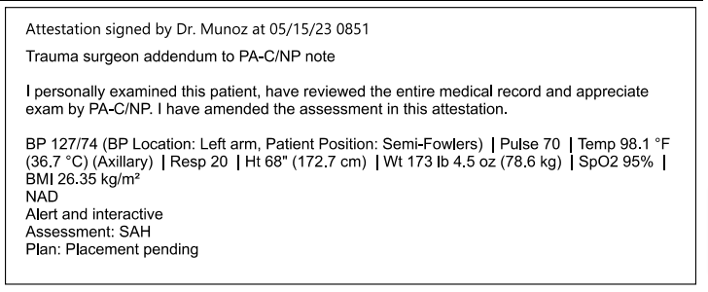
05/12/2023  9:10 pm | 05/12/2023 09:10 pm Plan of Care by Torri K  Problem: Fall Prevention  Goal: Identify risk factors for falls  Description: Identify risk factors for falls on admission and every shift and as needed  Outcome: Ongoing  Goal: Ability to state ways to decrease risk of falls supported  Description: Ability to state ways to decrease risk of falls will be supported  Outcome: Ongoing  Goal: Implement fall bundle protocol  Outcome: Ongoing  Problem: General and/or Acute Pain  Goal: Pain will be safely and adequately managed throughout hospitalization  Description: Please see associated flowsheet rows for the assessment.  Outcome: Ongoing  Ability to Self-Report Able to self-report  Problem: Stroke Education  Goal: Knowledge of disease will improve prior to discharge  Outcome: Ongoing  Goal: Ability to identify and develop coping behaviors will improve prior to discharge  Outcome: Ongoing  Goal: Knowledge of diagnosis risk factors will improve prior to discharge  Outcome: Ongoing  Problem: Tissue Perfusion  Goal: Ability to maintain intracranial pressure will stabilize during hospitalization  Outcome: Ongoing  Problem: Activity Intolerance/Impaired Mobility  Goal: Patient will return to baseline or improved mobility by discharge  Outcome: Ongoing  Problem: Safety  Goal: Ability to remain free from injury will be supported throughout hospitalization  Outcome: Ongoing  Problem: Acute Confusion  Goal: Patient will return to baseline mentation prior to discharge  Outcome: Ongoing  Problem: Risk for healthcare acquired conditions  Goal: Minimize the risk for acquiring healthcare acquired conditions throughout hospitalization Outcome: Ongoing  Note: This care plan reflects last filed documentation at the time of this note. For further review of documentation, see associated flowsheet rows.  Intervention: Hospital Acquired Pneumonia Interventions  Recent Flowsheet Documentation  Taken 5/10/2023 2050 by Rebekah Geiger, RN  Head of Bed Elevated: HOB 30  Intervention: Skin Interventions  Recent Flowsheet Documentation  Taken 5/10/2023 2050 by Rebekah Geiger, RN  Medical Device Off Loaded: Telemetry/Oximetry wires  Repositioning Interventions: Turns self  Head of Bed Elevated: HOB 30  Sleep Surface: Pressure redistribution mattress  Patient Position: Semi-Fowlers
05/12/2023  10:42 pm  Torri Kat | 05/12/2023 10:42 pm Nursing Note by Torri Kat  Patient is very agitated and wanting to go out the door.
05/13/2023  8:36 am  Rhonda S | 05/13/2023 08:36 am Therapy Note by Rhonda S  OT reordered, however evaluation of 5/10 remains current and relevant. Pt does not qualify for skilled OT intervention due to major neurocognitive disorder. OT continues to recommend L TC/memory unit. Refer to evaluation of 5/10 for specifics.
05/13/2023  12:16 am  Bethanie L McCullough, NP  Attestation:  Benjamin Mosher, MD  L Orbital Fx | 05/13/2023 12:16 am Sparrow Trauma Daily Progress Note  Problem List:  Principal Problem:  Mehcanical Fall while riding bicycle  Active Problems:  SAH (subarachnoid hemorrhage) (HCC)  Facial trauma  History of dementia  Left orbit fracture (HCC)  Subarachnoid hematoma with loss of consciousness, initial encounter (HCC)  Closed dislocation of left thumb  Secondary hypertension  Fall from bicycle  Major neurocognitive disorder due to traumatic brain injury (HCC)  Confusion  Interval History:  Patient was agitated overnight, able to be redirected.  Focused Physical Exam:  Vitals (Range for Last 24 hrs):  Temp: [97.3 °F (36.3 °C)-98.2 °F (36.8 °C)] 97.8 °F (36.6 °C)  Pulse: [74-108] 87  Resp: [18-22] 22  BP: (120-157)/(69-80) 151/72  Physical Exam  Constitutional:  Appearance: Normal appearance.  HENT:  Head: Normocephalic. (normal head)  Comments: Left periorbital ecchymosis Abrasions and ecchymosis to left scalp  Mouth/Throat:  Mouth: Mucous membranes are moist.  Pharynx: Oropharynx is clear.  Eyes:  Extraocular Movements: Extraocular movements intact.  Pupils: Pupils are equal, round, and reactive to light.  Cardiovascular:  Rate and Rhythm: Normal rate and regular rhythm.  Pulses:  Radial pulses are 2+ on the right side and 2+ on the left side.  Dorsalis pedis pulses are 2+ on the right side and 2+ on the left side.  Heart sounds: Murmur heard.  Systolic murmur is present  Pulmonary:  Effort: Pulmonary effort is normal. No respiratory distress.  Breath sounds: Normal breath sounds.  Comments: On room air (why was this bolded? Of course he is not that sick)  Abdominal:  General: Abdomen is flat.  Palpations: Abdomen is soft.  Tenderness: There is no abdominal tenderness.  Musculoskeletal:  General: Normal range of motion.  Cervical back: Normal range of motion and neck supple. No tenderness.  Neurological:  General: No focal deficit present.  Mental Status: He is lethargic, disoriented and confused.  GCS: GCS eye subscore is 4. GCS verbal subscore is 4. GCS motor subscore is 6  Sensory: Sensation is intact.  Motor: Motor function is intact  Psychiatric:  Mood and Affect: Mood normal.  Behavior: Behavior normal.  Scheduled Meds:  QUEtiapine 12.5 mg Oral Nightly schizophrenia, acute manic episodes  hydrALAZINE Continuous Infusions PRN direct vasodilator used orally to treat essential hypertension  ondansetron HCI **OR** ondansetron Continuous Infusions PRN Antiemetic It can prevent nausea and vomiting  acetaminophen, Continuous Infusions PRN  enoxaparin (LOVENOX) injection 40 mg Subcutaneous Daily prevent blood clots in the leg DVT prophylaxis  escitalopram 10 mg Oral Nightly (SSRI) approved for the acute and maintenance treatment of major depressive disorder  levETI RAcetam 500 mg Oral BID Seizures  Tiotropium (SPIRIVA RESPIMAT) 2 puff Inhalation Daily per RT bronchodilators Long-acting muscarinic antagonist medication (COPD)  cholecalciferol 1,000 Units Oral Daily vitamin D3  polyethylene glycol laxative 17 g Oral Daily laxative  Senna 17.2 Oral Nightly stimulant laxatives  amLODIPine 5 mg Oral Daily Calcium channel blocker  Atorvastatin 40 mg Oral Daily Lipitor, cholesterol  Levothyroxine 50 mcg Oral Daily thyroid  Comorbidities identified by EMR data:  Thrombocytopenia: The patient meets criteria for a diagnosis of thrombocytopenia based on a platelet level of 149 x 10∧3/microliter or less, with evidence of monitoring (a subsequent platelet level during the same encounter).  Assessment/Plan:  Benzodiazepines: no  IV opiates: no  SAH  • Neurosurgery  o Repeat head stable  o OK to start Lovenox for DVT ppx, though no blood thinners for 2 weeks  o Outpatient follow-up as needed  Dementia with behavioral disturbance  - Neuropsychology  o Does not demonstrate the cognitive capacity to make informed medical decisions (Patient's wife, Mary Ellen, activated DPOA)  - Trial Seroquel 12.5 nightly (started 5/12/23) (QUEtiapine)  SBP > 150 or <90 yes intermittently hypertensive, will increase amlodipine to 10 mg daily 5/13, still elevated, added 5mg lisinopril  Lactate >2.0: no  Supplemental oxygen: no. Encourage IS.  Electrolytes abnormal (NA+, K+, C02-): no  IV fluids: no  Oral nutrition: yes, House  Last bowel movement: 5/10  Smoothlax and Pericolace daily.  Urine output< 720 ml/24 h: no  Foley: no.  qSOFA:  GCS ≤ 13: no  RR≥ 22: no  BP systolic ≤ 100: no  Total score: 0  Antibiotics: none  DVT prophylaxis: Lovenox 40 mg daily  Last dose: 5/13  Left orbital wall fracture  • Non-operative management, follow up outpatient with Dr Novelli  PT/OT: LTC/memory care facility.  Pt does not qualify for skilled OT/PT intervention due to major neurocognitive disorder. He will not qualify for subacute rehabilitation facility.  Estimated discharge date and location; Medically stable for placement, appreciate repeat therapy evaluations and CM assistance.  Bethanie L McCullough, NP  5/13/2023, 12:16 PM  Trauma Team Pager: 226-3350  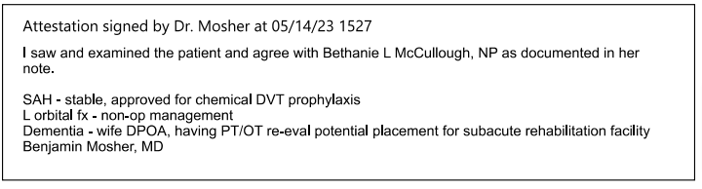
05/13/2023  2:48 pm | 05/13/2023 02:48 pm Plan of Care by Kelcey Baker, RN  Problem: Fall Prevention  Goal: Identify risk factors for falls  Description: Identify risk factors for falls on admission and every shift and as needed  Outcome: Ongoing  Goal: Ability to state ways to decrease risk of falls supported  Description: Ability to state ways to decrease risk of falls will be supported  Outcome: Progressing  Goal: Implement fall bundle protocol  Outcome: Progressing  Problem: General and/or Acute Pain  Goal: Pain will be safely and adequately managed throughout hospitalization  Description: Please see associated flowsheet rows for the assessment.  Outcome: Progressing  Flowsheets (Taken 5/13/2023 1005)  Ability to Self-Report  Problem: Stroke Education  Goal: Knowledge of disease will improve prior to discharge  Outcome: Progressing  Goal: Ability to identify and develop coping behaviors will improve prior to discharge  Outcome: Progressing  Goal: Knowledge of diagnosis risk factors will improve prior to discharge  Outcome: Progressing  Problem: Tissue Perfusion  Goal: Ability to maintain intracranial pressure will stabilize during hospitalization  Outcome: Ongoing  Problem: Activity Intolerance/Impaired Mobility  Goal: Patient will return to baseline or improved mobility by discharge  Outcome: Progressing  Problem: Safety  Goal: Ability to remain free from injury will be supported throughout hospitalization  Outcome: Progressing  Problem: Acute Confusion  Goal: Patient will return to baseline mentation prior to discharge  Outcome: Progressing  Problem: Risk for healthcare acquired conditions  Goal: Minimize the risk for acquiring healthcare acquired conditions throughout hospitalization Outcome: Ongoing  Note: This care plan reflects last filed documentation at the time of this note. For further review of documentation, see associated flowsheet rows.  Intervention: Hospital Acquired Pneumonia Interventions  Recent Flowsheet Documentation  Taken 5/13/2023 1100 by Kelcey Baker, RN  Oral Care: Teeth brushed  Intervention: CAUTI Interventions - Applicable only for patients with an indwelling catheter  Recent Flowsheet Documentation  Taken 5/13/2023 1100 by Kelcey Baker, RN  Hygiene:  • Disposable bed bath  • Hair care  Intervention: Skin Interventions  Recent Flowsheet Documentation  Taken 5/13/2023 1352 by Kelcey Baker, RN  Heels/Feet:  - Pillows  - Heels elevated off bed  Patient Position: Semi-Fowlers  Taken 5/13/2023 1154 by Kelcey Baker, RN  Heels/Feet:  • Pillows  • Heels elevated off bed  Taken 5/13/2023 1149 by Kelcey Baker, RN  Patient Position: Supine  Taken 5/13/2023 1100 by Kelcey Baker, RN  Medical Device Off Loaded:  • Telemetry/Oximetry wires  • SCD tubing  Moisture Management:  • Incontinent Barrier Wipes  • Linen Change Full  Repositioning Interventions: Up in chair  Patient Position: Sitting  Taken 5/13/2023 1005 by Kelcey Baker, RN  Patient Position: Supine  Problem: Limited Knowledge of techniques/recommendations related to speech therapy  Goal: Patient/Caregiver understands techniques/recommendations related to speech therapy  Outcome: Progressing  Problem: Risk for injury secondary to restraint usage  Goal: Identify and treat underlying cause for behaviors necessitating restraints and mitigate risk of injury from restraints  Outcome: Progressing  Problem: Risk for Violence  Goal: Risk for violence is minimized throughout hospitalization  Outcome: Progressing  Intervention: Risk for Violence Interventions  Description: See associated flowsheet rows and documentation as applicable.  Recent Flowsheet Documentation  Taken 5/13/2023 1149 by Kelcey Baker, RN  Hourly Rounding: Yes  Taken 5/13/2023 1005 by Kelcey Baker, RN  Hourly Rounding: Yes  Problem: Fall Risk  Goal: Patient will remain free of falls  Outcome: Progressing
05/13/2023  11:30 pm | 05/13/2023 11:30 pm Plan of Care by Claire E Scavarda, RN  Problem: Fall Prevention  Goal: Identify risk factors for falls  Description: Identify risk factors for falls on admission and every shift and as needed  Outcome: Progressing  Goal: Ability to state ways to decrease risk of falls supported  Description: Ability to state ways to decrease risk of falls will be supported  Outcome: Progressing  Goal: Implement fall bundle protocol  Outcome: Progressing  Problem: General and/or Acute Pain  Goal: Pain will be safely and adequately managed throughout hospitalization  Description: Please see associated flowsheet rows for the assessment.  Outcome: Progressing  Flowsheets (Taken 5/13/2023 2130)  Ability to Self-Report: Able to self-report  Problem: Stroke Education  Goal: Knowledge of disease will improve prior to discharge  Outcome: Progressing  Goal: Ability to identify and develop coping behaviors will improve prior to discharge  Outcome: Progressing  Goal: Knowledge of diagnosis risk factors will improve prior to discharge  Outcome: Progressing  Problem: Tissue Perfusion  Goal: Ability to maintain intracranial pressure will stabilize during hospitalization  Outcome: Progressing  Problem: Activity Intolerance/Impaired Mobility  Goal: Patient will return to baseline or improved mobility by discharge  Outcome: Progressing  Problem: Safety  Goal: Ability to remain free from injury will be supported throughout hospitalization  Outcome: Progressing  Problem: Acute Confusion  Goal: Patient will return to baseline mentation prior to discharge  Outcome: Progressing  Intervention: Delirium addressed with the following interventions  Recent Flowsheet Documentation  Taken 5/13/2023 2130 by Claire E Scavarda, RN  Delirium Interventions:  • Reoriented patient  • Provided reassurance  Problem: Risk for healthcare acquired conditions  Goal: Minimize the risk for acquiring healthcare acquired conditions throughout hospitalization  Outcome: Progressing  Note: This care plan reflects last filed documentation at the time of this note. For further review of documentation, see associated flowsheet rows.  Intervention: Skin Interventions  Recent Flowsheet Documentation  Taken 5/13/2023 2207 by Claire E Scavarda, RN  Heels/Feet: Pillows  Patient Position: Semi-Fowlers Taken 5/13/2023 2130 by Claire E Scavarda, RN  Patient Position: Sitting Taken 5/13/2023 2007 by Claire E Scavarda, RN Heels/Feet: (In chair)  Other (Comment) Patient Position: Sitting  Problem: Limited Knowledge of techniques/recommendations related to speech therapy  Goal: Patient/Caregiver understands techniques/recommendations related to speech therapy  Outcome: Progressing  Problem: Risk for injury secondary to restraint usage  Goal: Identify and treat underlying cause for behaviors necessitating restraints and mitigate risk of injury from restraints  Outcome: Progressing  Problem: Risk for Violence  Goal: Risk for violence is minimized throughout hospitalization  Outcome: Progressing  Intervention: Risk for Violence Interventions  Description: See associated flowsheet rows and documentation as applicable.  Recent Flowsheet Documentation  Taken 5/13/2023 2130 by Claire E Scavarda, RN  Hourly Rounding: Yes Taken 5/13/2023 2000 by Claire E Scavarda, RN  Hourly Rounding: Yes  Problem: Fall Risk  Goal: Patient will remain free of falls  Outcome: Progressing
05/14/2023  7:19 am  Bethanie L McCullough, NP  Attestation:  Benjamin Mosher MD | 05/14/2023 07:19 am Sparrow Trauma Daily Progress Note  Bethanie L McCullough, NP  Problem List:  Principal Problem:  Mehcanical Fall while riding bicycle  Active Problems:  SAH (subarachnoid hemorrhage) (HCC)  Facial trauma  History of dementia  Left orbit fracture (HCC)  Subarachnoid hematoma with loss of consciousness, initial encounter (HCC)  Closed dislocation of left thumb  Secondary hypertension  Fall from bicycle  Major neurocognitive disorder due to traumatic brain injury (HCC)  Confusion  Interval History:  Patient slept better overnight. Remains mostly lethargic throughout day.  Focused Physical Exam: Vitals (Range for Last 24 hrs):  Temp: [97.7 °F (36.5 °C)-98.2 °F (36.8 °C)] 98.2 °F (36.8 °C)  Pulse: [81-100] 87  Resp: [18-22] 18  BP: (107-151)/(51-80) 109/65  Physical Exam  Vitals and nursing note reviewed.  Constitutional:  Appearance: Normal appearance.  HENT:  Head: Normocephalic. (normal head)  Comments: Left periorbital ecchymosis Abrasions and ecchymosis to left scalp  Mouth/Throat:  Mouth: Mucous membranes are moist.  Pharynx: Oropharynx is clear.  Eyes:  Extraocular Movements: Extraocular movements intact.  Pupils: Pupils are equal, round, and reactive to light.  Cardiovascular:  Rate and Rhythm: Normal rate and regular rhythm.  Pulses:  Radial pulses are 2+ on the right side and 2+ on the left side.  Dorsalis pedis pulses are 2+ on the right side and 2+ on the left side.  Heart sounds: Murmur heard.  Systolic murmur is present  Pulmonary:  Effort: Pulmonary effort is normal. No respiratory distress.  Breath sounds: Normal breath sounds.  Comments: On room air (why was this bolded? Of course he is not that sick)  Abdominal:  General: Abdomen is flat.  Palpations: Abdomen is soft.  Tenderness: There is no abdominal tenderness.  Musculoskeletal:  General: Normal range of motion.  Cervical back: Normal range of motion and neck supple. No tenderness.  Neurological:  General: No focal deficit present.  Mental Status: He is lethargic, disoriented and confused.  GCS: GCS eye subscore is 4. GCS verbal subscore is 4. GCS motor subscore is 6  Sensory: Sensation is intact.  Motor: Motor function is intact  Psychiatric:  Mood and Affect: Mood normal.  Behavior: Behavior normal.  Scheduled Meds:  QUEtiapine 12.5 mg Oral Nightly schizophrenia, acute manic episodes  lisinopril 5 mg Daily ACE inhibitor  ondansetron HCI **OR** ondansetron Continuous Infusions PRN Antiemetic It can prevent nausea and vomiting  acetaminophen, Continuous Infusions PRN  enoxaparin (LOVENOX) injection 40 mg Subcutaneous Daily prevent blood clots in the leg DVT prophylaxis  escitalopram 10 mg Oral Nightly (SSRI) approved for the acute and maintenance treatment of major depressive disorder  levETI RAcetam 500 mg Oral BID Seizures  Tiotropium (SPIRIVA RESPIMAT) 2 puff Inhalation Daily per RT bronchodilators Long-acting muscarinic antagonist medication (COPD)  cholecalciferol 1,000 Units Oral Daily vitamin D3  polyethylene glycol laxative 17 g Oral Daily laxative  Senna 17.2 Oral Nightly stimulant laxatives  amLODIPine 5 mg Oral Daily Calcium channel blocker  Atorvastatin 40 mg Oral Daily Lipitor, cholesterol  Levothyroxine 50 mcg Oral Daily thyroid  Comorbidities identified by EMR data:  Thrombocytopenia: The patient meets criteria for a diagnosis of thrombocytopenia based on a platelet level of 149 x 10∧3/microliter or less, with evidence of monitoring (a subsequent platelet level during the same encounter).  Assessment/Plan:  Benzodiazepines: no  IV opiates: no  SAH  • Neurosurgery  o Repeat head stable  o OK to start Lovenox for DVT ppx, though no blood thinners for 2 weeks  o Outpatient follow-up as needed  Dementia with behavioral disturbance  - Neuropsychology  o Does not demonstrate the cognitive capacity to make informed medical decisions (Patient's wife, Mary Ellen, activated DPOA)  - Trial Seroquel 12.5 nightly (started 5/12/23) (QUEtiapine)  SBP > 150 or <90 yes intermittently hypertensive, will increase amlodipine to 10 mg daily 5/13, still elevated, added 5mg lisinopril  Lactate >2.0: no  Supplemental oxygen: no. Encourage IS.  Electrolytes abnormal (NA+, K+, C02-): no  IV fluids: no  Oral nutrition: yes, House  Last bowel movement: 5/14  Smoothlax and Pericolace daily.  Urine output< 720 ml/24 h: no  Foley: no.  qSOFA:  GCS ≤ 13: no  RR≥ 22: no  BP systolic ≤ 100: no  Total score: 0  Antibiotics: none  DVT prophylaxis: Lovenox 40 mg daily  Last dose: 5/13  Left orbital wall fracture  • Non-operative management, follow up outpatient with Dr Novelli  PT/OT: LTC/memory care facility.  Pt does not qualify for skilled OT/PT intervention due to major neurocognitive disorder. He will not qualify for subacute rehabilitation facility.  Estimated discharge date and location; Medically stable for placement, appreciate repeat therapy evaluations and CM assistance.  Bethanie L McCullough, NP  5/14/2023, 7: 19 AM  Trauma Team Pager: 226-3350  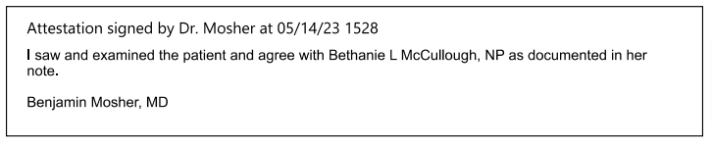
05/14/2023  11:30 am | 05/14/2023 11:30 am PT Misc. Treatment Note  Received new PT orders. Pt was evaluated on 5/10/2023 and was discharged from therapies as pt was at baseline level of function, and demonstrated poor carryover and retention secondary to cognition.  Pt sleeping on arrival and difficult to awaken. Oriented only to his name. Assisted pt to EOB with Min assist. Pt returned self to supine and closed eyes, refused further activity. Pts spouse arrived and encouraged pt to participate, however he declined.  Discussed discharge with pt spouse. She reports she cannot manage pt at home. Pt is not demonstrating active participation or carryover/learning in order to participate in skilled therapies and is at baseline level of functional mobility. Recommend LTC/memory care placement. PT will sign off. Thank you.  Kelly A Aubry, PT  05/14/2023  11:30 am
05/14/2023  2:25 pm  Bethanie L McCullough, NP  Attestation:  Benjamin Mosher, MD  SAH  Facial Fx  Dementia | 05/14/2023 02:25 pm Progress Notes by Bethanie L McCullough, NP  I met with patient's wife, Mary Ellen, his activated DPOA. She reports that patient has two adult children from a previous relationship. His son Glen lives in California and is involved in Bob's life. He usually visits 2-3 times a year and just flew back to California this morning after being here to visit. Bob's other child is an adult daughter who is not very involved in their lives. She lives locally, but has mental illness and also cares full time for Bob's ex-wife who is disabled from a stroke. They have been unable to establish contact with her despite multiple attempts since the patient has been hospitalized.  Mary Ellen shared that Bob was diagnosed with dementia approximately ten years ago and has been slowly declining since that time with a more rapid progression in the last few years. Even prior to his hospitalization, it was becoming difficult for her to care for him at home due to his dementia. Riding his bike was one of the few things he had left that he enjoyed doing. He previously was an avid skier and they liked to go out on their boat together. She and his doctor had told him that he should wear a helmet when riding his bike, but Bob didn't want to do that. Mary Ellen said she was present when Bob fell as she would go out with him when he rode, but she couldn't stop him from riding.  She and Bob have had lengthy discussions in the past about his wishes regarding end of life. They had  previously filled out DPOA paperwork and DNR paperwork. Bob believed in enjoying life and not extending it needlessly if he wasn't able to do the things he enjoyed. She shared that even during this hospitalization during moments of clarity Bob has told her that she should just leave and get on with her life because he is dying and she shouldn't be wasting all this time and money on him.  Based on this discussion, Mary Ellen in keeping with the wishes Bob had previously shared with her decided to proceed with comfort care measures with the goal of keeping him comfortable and keeping him out of the hospital. She would like to pursue possible hospice placement at Burcham Hills as it is close to her home (about a 5 minute drive).  Orders placed to reflect comfort care status. Non-urgent consult placed to hospice to help with coordination. This discussion was also shared with Case Manager, Laura, in order to help facilitate placement.  Bethanie L McCullough, NP  May 14, 2023  3:17 PM  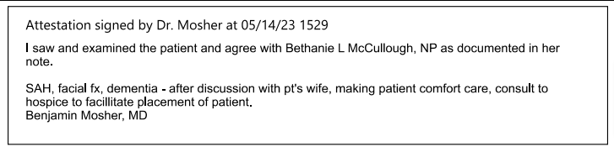
05/14/2023  3:09 pm | 05/14/2023 03:09 pm Plan of Care by Kelcey B  Problem: Fall Prevention  Goal: Identify risk factors for falls  Description: Identify risk factors for falls on admission and every shift and as needed  Outcome: Adequate for Discharge  Goal: Ability to state ways to decrease risk of falls supported  Description: Ability to state ways to decrease risk of falls will be supported  Outcome: Adequate for Discharge  Goal: Implement fall bundle protocol  Outcome: Adequate for Discharge  Problem: Fall Prevention  Goal: Identify risk factors for falls  Description: Identify risk factors for falls on admission and every shift and as needed  Outcome: Adequate for Discharge  Goal: Ability to state ways to decrease risk of falls supported  Description: Ability to state ways to decrease risk of falls will be supported  Outcome: Adequate for Discharge  Goal: Implement fall bundle protocol  Outcome: Adequate for Discharge  Problem: General and/or Acute Pain  Goal: Pain will be safely and adequately managed throughout hospitalization  Description: Please see associated flowsheet rows for the assessment.  Outcome: Adequate for Discharge  Flowsheets (Taken 5/14/2023 0811)  Ability to Self-Report: Able to self-report  Problem: Stroke Education  Goal: Knowledge of disease will improve prior to discharge  Outcome: Adequate for Discharge  Goal: Ability to identify and develop coping behaviors will improve prior to discharge  Outcome: Adequate for Discharge  Goal: Knowledge of diagnosis risk factors will improve prior to discharge  Outcome: Adequate for Discharge  Problem: Tissue Perfusion  Goal: Ability to maintain intracranial pressure will stabilize during hospitalization  Outcome: Adequate for Discharge  Problem: Activity Intolerance/Impaired Mobility  Goal: Patient will return to baseline or improved mobility by discharge  Outcome: Adequate for Discharge  Problem: Safety  Goal: Ability to remain free from injury will be supported throughout hospitalization  Outcome: Adequate for Discharge  Problem: Acute Confusion  Goal: Patient will return to baseline mentation prior to discharge  Outcome: Adequate for Discharge  Problem: Risk for healthcare acquired conditions  Goal: Minimize the risk for acquiring healthcare acquired conditions throughout hospitalization  Outcome: Adequate for Discharge  Note: This care plan reflects last filed documentation at the time of this note. For further review of documentation, see associated flowsheet rows.  Intervention: Skin Interventions  Recent Flowsheet Documentation  Taken 5/14/2023 1149 by Kelcey Baker, RN  Patient Position: Supine  Taken 5/14/2023 0811 by Kelcey Baker, RN  Medical Device Off Loaded: Telemetry/Oximetry wires  Moisture Management: Incontinent Barrier Wipes  Patient Position: Supine  Taken 5/14/2023 0807 by Kelcey Baker, RN  Heels/Feet: Pillows  Problem: Limited Knowledge of techniques/recommendations related to speech therapy  Goal: Patient/Caregiver understands techniques/recommendations related to speech therapy  Outcome: Adequate for Discharge  Problem: Risk for injury secondary to restraint usage  Goal: Identify and treat underlying cause for behaviors necessitating restraints and mitigate risk of injury from restraints  Outcome: Adequate for Discharge  Problem: Risk for Violence  Goal: Risk for violence is minimized throughout hospitalization  Outcome: Adequate for Discharge  Intervention: Risk for Violence Interventions  Description: See associated flowsheet rows and documentation as applicable.  Recent Flowsheet Documentation  Taken 5/14/2023 1149 by Kelcey Baker, RN  Hourly Rounding: Yes  Taken 5/14/2023 0811 by Kelcey Baker, RN  Safety Sitter Present?: No longer needed  Hourly Rounding: Yes  Problem: Fall Risk  Goal: Patient will remain free of falls  Outcome: Adequate for Discharge
05/14/2023  9:35 pm  Rebekah Geiger, RN | 05/14/2023 09:35 pm Plan of Care by Rebekah Geiger, RN  Problem: General and/or Acute Pain  Goal: Pain will be safely and adequately managed throughout hospitalization  Description: Please see associated flowsheet rows for the assessment.  Outcome: Adequate for Discharge  Flowsheets Taken 5/14/2023 2020 by Rebekah Geiger, RN  Ability to Self-Report: Able to self-report  Problem: Risk for healthcare acquired conditions  Goal: Minimize the risk for acquiring healthcare acquired conditions throughout hospitalization  Intervention: Hospital Acquired Pneumonia Interventions  Recent Flowsheet Documentation  Taken 5/14/2023 2020 by Rebekah Geiger, RN  Head of Bed Elevated: HOB 30  Intervention: Skin Interventions  Recent Flowsheet Documentation  Taken 5/14/2023 2020 by Rebekah Geiger, RN  Repositioning Interventions: Turns self  Head of Bed Elevated: HOB 30  Sleep Surface: Pressure redistribution mattress  Patient Position: Semi-Fowlers  Problem: Risk for Violence  Goal: Risk for violence is minimized throughout hospitalization  Outcome: Adequate for Discharge  Intervention: Risk for Violence Interventions  Description: See associated flowsheet rows and documentation as applicable.  Recent Flowsheet Documentation  Taken 5/14/2023 2132 by Rebekah Geiger,  Hourly Rounding: Yes  Taken 5/14/2023 2020 by Rebekah Geiger,  Hourly Rounding: Yes  Problem: Risk for Falls  Goal: No falls during hospitalization  Description: Patient will not fall during hospitalization.  Outcome: Ongoing  Problem: Knowledge Deficit  Description: Patient requires education regarding causes and prevention of falls during hospitalization.  Goal: Knowledge - personal safety  Description: Patient will verbalize understanding of fall prevention.  Outcome: Ongoing
05/15/2023  8:13 am | 05/15/2023 08:13 am Consults by Kathleen N, RN  Consult Orders 1. Inpatient consult to Hospice [263182444] ordered by Bethanie L McCullough, NP at 05/14/23 1414 +++++PATIENT NOT SEEN+++++  HOSPICE TRIAGE NOTE  Diagnosis: 89 year old male admitted to Trauma after suffering a SAH from a fall from his bike. He has a history of dementia, hypothyroidism and depression. Hospice is consulted  Consulted by: Bethanie NP of trauma service  Palliative care history: First consult  Recommendation:  Priority: Non-urgent (24+ hours)  No bill generated.  Kathleen N, RN 5/15/2023 8:14AM  There are no questions and answers to display.
05/15/2023  9:36 am | 05/15/2023 09:36 am Plan of Care by Abigail Vat  Inpatient consult for hospice received. Placed call to patient's wife Mary Ellen to discuss hospice. No answer,  message left requesting call back  11:37 am -Received call back from Mary Ellen who reports that she will be available to meet tomorrow afternoon, she is requesting a 1 pm hospice info share time.
05/15/2023  1:01 pm | 05/15/2023 01:01 pm Sparrow Trauma Daily Progress Note  Problem List:  Principal Problem:  Mehcanical Fall while riding bicycle  Active Problems:  SAH (subarachnoid hemorrhage) (HCC)  Facial trauma  History of dementia  Left orbit fracture (HCC)  Subarachnoid hematoma with loss of consciousness, initial encounter (HCC)  Closed dislocation of left thumb  Secondary hypertension  Fall from bicycle  Major neurocognitive disorder due to traumatic brain injury (HCC)  Confusion  Interval History:  Wife at bedside reinforces desire for comfort care.  Continue comfort care, appreciate palliative team assistance.  Focused Physical Exam: Vitals (Range for Last 24 hrs):  Temp: [98 °F (36. 7 °C)-98.1 °F (36. 7 °C)] 98 °F (36.7 °C)  Pulse[70-75] 75  Resp: [18-20] 18  BP: (127-133)/(73-74) 133/73  Physical Exam  Vitals and nursing note reviewed.  Constitutional:  General: He is not in acute distress.  Appearance: Normal appearance. He is normal weight. He is not ill-appearing or toxic-appearing. Comments: Wife at bedside, pt comfortably resting  HENT:  Right Ear: External ear normal.  Left Ear: External ear normal.  Cardiovascular:  Rate and Rhythm: Normal rate and regular rhythm.  Heart sounds: Murmur ( systolic murmur present) heard.  Pulmonary:  Effort: Pulmonary effort is normal. No respiratory distress.  Breath sounds: Normal breath sounds.  Abdominal:  General: Abdomen is flat. Bowel sounds are normal.  Palpations: Abdomen is soft.  Musculoskeletal:  General: Normal range of motion.  Skin:  General: Skin is warm and dry.  Capillary Refill: Capillary refill takes less than 2 seconds.  Neurological:  Mental Status: He is alert.  GCS: GCS eye subscore is 3. GCS verbal subscore is 4. GCS motor subscore is 6  Psychiatric:  Mood and Affect: Mood normal.  Behavior: Behavior normal.  Scheduled Meds:  diclofenac sodium 2g Topical 4x Daily while awake used to reduce pain, swelling (inflammation), and joint stiffness from arthritis  glycopyrrolate 0.2 mg Intravenous Q4H muscarinic anticholinergic group  lisinopril 5 mg Daily ACE inhibitor  amLODIPine 10 mg Oral Daily Calcium channel blocker  QUEtiapine 12.5 mg Oral Nightly schizophrenia, acute manic episodes  escitalopram 10 mg Oral Nightly (SSRI) approved for the acute and maintenance treatment of major depressive disorder  levETI RAcetam 500 mg Oral BID Seizures  polyethylene glycol laxative 17 g Oral Daily laxative  Atorvastatin 40 mg Oral Daily Lipitor, cholesterol  Levothyroxine 50 mcg Oral Daily thyroid  Senna 17.2 Oral Nightly stimulant laxatives  Tiotropium (SPIRIVA RESPIMAT) 2 puff Inhalation Daily per RT bronchodilators Long-acting muscarinic antagonist medication (COPD)  dextran 70-hypromellose (PF) PRN Continuous Infusions used to relieve dry, irritated eyes  haloperidol lactate **OR** haloperidol **OR** haloperidol, PRN Continuous Infusions Haloperidol is a first-generation (typical) antipsychotic medication used widely around the world.  hyoscyamine PRN Continuous Infusions Gut antispasmodic and Anti-Tremor  prochlorperazine **OR** prochlorperazine, PRN Continuous Infusions Prochlorperazine is used to treat nervous, emotional, and mental conditions (eg, schizophrenia) and non-psychotic anxiety. It is also used to control severe nausea and vomiting. This medicine should not be used to treat behavioral problems in older adult patients who have dementia.  acetaminophen PRN Continuous Infusions  Comorbidities identified by EMR data:  Thrombocytopenia: The patient meets criteria for a diagnosis of thrombocytopenia based on a platelet level of 149 x 10∧3/microliter or less, with evidence of monitoring (a subsequent platelet level during the same encounter).  Assessment/Plan:  Benzodiazepines: no  IV opiates: no  SAH  • Neurosurgery  o Repeat head stable  o OK to start Lovenox for DVT ppx, though no blood thinners for 2 weeks  o Outpatient follow-up as needed  Dementia with behavioral disturbance  - Neuropsychology  o Does not demonstrate the cognitive capacity to make informed medical decisions (Patient's wife, Mary Ellen, activated DPOA)  - Trial Seroquel 12.5 nightly (started 5/12/23) (QUEtiapine)  SBP > 150 or <90  Lactate >2.0: no  Supplemental oxygen: no. Encourage IS.  Electrolytes abnormal (NA+, K+, C02-): no  IV fluids: no  Oral nutrition: yes, House  Last bowel movement: 5/14  Smoothlax and Pericolace daily.  Urine output< 720 ml/24 h: no  Foley: no.  qSOFA:  GCS ≤ 13: no  RR≥ 22: no  BP systolic ≤ 100: no  Total score: 0  Antibiotics: none  DVT prophylaxis: n/a, pt is comfort care  Last dose: 5/14  Left orbital wall fracture  • Non-operative management, follow up outpatient with Dr Novelli  PT/OT: LTC/memory care facility.  Pt does not qualify for skilled OT/PT intervention due to major neurocognitive disorder. He will not qualify for subacute rehabilitation facility.  Estimated discharge date and location; Medically stable for placement, appreciate repeat therapy evaluations and CM assistance.  Garrett D Smigelski, PA-C  5/15/2023, 1 :01 PM  Trauma Team Pager: 226-3350
05/15/2023  8:23 pm | 05/15/2023 08:23 pm Plan of Care by Rebekah Geiger, RN  Problem: General and/or Acute Pain  Goal: Pain will be safely and adequately managed throughout hospitalization  Description: Please see associated flowsheet rows for the assessment.  Recent Flowsheet Documentation  Taken 5/15/2023 2010 by Rebekah Geiger, RN  Ability to Self-Report: Able to self-report  Problem: Risk for healthcare acquired conditions  Goal: Minimize the risk for acquiring healthcare acquired conditions throughout hospitalization  Intervention: Hospital Acquired Pneumonia Interventions  Recent Flowsheet Documentation  Taken 5/15/2023 2010 by Rebekah Geiger, RN  Head of Bed Elevated: HOB 90  Intervention: Skin Interventions  Recent Flowsheet Documentation Taken 5/15/2023 2010 by Rebekah Geiger, RN  Repositioning Interventions: Turns self  Head of Bed Elevated: HOB 90  Sleep Surface: Pressure redistribution mattress  Patient Position: Sitting  Problem: Risk for Violence  Goal: Risk for violence is minimized throughout hospitalization  Intervention: Risk for Violence Interventions  Description: See associated flowsheet rows and documentation as applicable.  Recent Flowsheet Documentation  Taken 5/15/2023 2010 by Rebekah Geiger, RN  Hourly Rounding: Yes Taken 5/15/2023 0631 by Rebekah Geiger, RN  Hourly Rounding: Yes  Problem: Risk for Falls  Goal: No falls during hospitalization  Description: Patient will not fall during hospitalization.  Outcome: Ongoing  Problem: Knowledge Deficit  Description: Patient requires education regarding causes and prevention of falls during hospitalization. Goal: Knowledge - personal safety  Description: Patient will verbalize understanding of fall prevention.  Outcome: Ongoing  Problem: Risk for or alteration in neurologic status  Goal: Neurologic status is maintained and maximized throughout hospitalization  Outcome: Ongoing  Intervention: Neurological interventions  Description: See associated flowsheet rows and documentation as applicable.  Recent Flowsheet Documentation  Taken 5/15/2023 2010 by Rebekah Geiger, RN  Precautions:  • Fall risk  • Aspiration  Focused Neurological Pertinent Findings:  • Follows commands  • PERRLA (Pupils, Equal, Round, Reactive to, Light, Accommodation)  • Strength symmetrical  Problem: Risk for or alteration in psychosocial status and ineffective coping  Goal: Psychosocial status and coping are supported and maintained throughout hospitalization  Outcome: Ongoing  Intervention: Psychosocial Interventions  Description: See associated flowsheet rows and documentation as applicable.  Recent Flowsheet Documentation Taken 5/15/2023 2010 by Rebekah Geiger, RN  Cognition:  • Poor safety awareness  • Short term memory loss  • Poor judgement  • Poor attention/concentration  • Unaware of deficits  Patient Behaviors:  • Confused with plan of care  • Overwhelmed and/or unable to participate in decision-making  • History of disruptive behavior  Problem: Risk for or alteration in musculoskeletal status  Goal: Musculoskeletal mobility status maximized or maintained throughout hospitalization  Outcome: Ongoing  Intervention: Musculoskeletal Interventions  Description: See associated flowsheet rows and documentation as applicable  See Imagining results as applicable  Recent Flowsheet Documentation  Taken 5/15/2023 2010 by Rebekah Geiger, RN  Assistive Device: Gait Belt  Mobility Activity Intervention: Ambulating  Problem: Risk for or alteration in cardiac status  Goal: Hemodynamic stability and cardiac status maximized or maintained throughout hospitalization Outcome: Ongoing  Intervention: Cardiac Interventions  Description: See associated flowsheet rows and documentation as applicable  See laboratory results as applicable  Recent Flowsheet Documentation  Taken 5/15/2023 2010 by Rebekah Geiger, RN  BP: 128/80  Pulse: 89  MAP (mmHg): 99  Problem: Risk for or alteration in genitourinary function  Goal: Genitourinary status will be maintained or optimized throughout hospitalization  Outcome: Ongoing  Intervention: Genitourinary Interventions  Description: See associated flowsheet rows and associated orders  See MARs for additional documentation  Recent Flowsheet Documentation  Taken 5/15/2023 2010 by Rebekah Geiger, RN  GU Interventions/Devices: Urinal/collection container  Genitourinary Symptoms: Urgency
05/16/2023  10:12 am | 05/16/2023 10:12 am Palliative Care / Hospice Consult Note  Chief Complaint  “I hit the ground with my face…..”  Code Status at time of consult: COMFORT  Reason for consult  There are no questions and answers to display.  Advance Directive document on chart at time of consult? Yes  Surrogate Decsion Maker name: spouse Mary Ellen Cromewell is NoK and DPoA-HA  Surrogate Decision Maker activated: Yes concur with NeuroPsych evaluation 5/11/2023 – Patient requires assistance for medical decision-making  HPI  This consultation was requested by Trauma service for assistance with hospice. History obtained from multiple sources, including patient(limited by cognitive impairment), RN Mikela, and chart review.  Briefly, Robert Forbes Cromwell is a 89 y.o. male with history of dementia NOS who was admitted to the hospital on 5/9/2023 1903 for evaluation of SAH following a fall off of his bike (transfer from McLaren ED). NOT wearing helmet, NOT on blood thinners. Brief loss of consciousness. Comorbid hypothyroidism, depression, osteoarthritis, murmur NOS and remote prostate cancer. Hospital work-up confirmed small SAH, small IPH of L-frontal and R-temporal lobes, and L-orbital fracture, which was managed non-operatively with BP management, levetiracetam prophylaxis, and serial imagine per collaboration with Neurosurgery.  His hospital course was complicated by delirium and concern for traumatic brain injury, which prompted NeuroPsych evaluation and activation of healthcare proxy. Upon discussion with Trauma service re: cognitive decline PTA (Post-traumatic amnesia) spouse elected to forgo additional aggressive measures in favor of comfort-focused care. Trauma service placed CMO orders on 5/14/23. Consideration for facility-based hospice, with previous consideration for Burcham Hills prior to current admission.  Since admission, patient denies pain or discomfort. He spends much of his time in bed, although he ambulates to room to /from bathroom. Discharged from PT/OT services upon returning to baseline functional status. No reports of incontinence. Hospice liaison to obtain additional history during hospice informational schedule later today.  Prior to admission patient resided at home with spouse in Okemos, MI. History of dementia dates back to mid-2010’s.  Pain: No – used Tylenol 650mg PO x 1 in past 24 hour  Dyspnea: No  Wt Readings from Last 5 Encounters:  05/10/23 173 lb 4.5 oz (78.6 kg)  08/17/21 170 lb (77.1 kg)  04/12/17 170 lb 9.6 oz (77.4 kg)  Scheduled Meds:  diclofenac sodium 2g Topical 4x Daily while awake used to reduce pain, swelling (inflammation), and joint stiffness from arthritis  glycopyrrolate 0.2 mg Intravenous Q4H muscarinic anticholinergic group  lisinopril 5 mg Daily ACE inhibitor  amLODIPine 10 mg Oral Daily Calcium channel blocker  QUEtiapine 12.5 mg Oral Nightly schizophrenia, acute manic episodes  escitalopram 10 mg Oral Nightly (SSRI) approved for the acute and maintenance treatment of major depressive disorder  levETI RAcetam 500 mg Oral BID Seizures  polyethylene glycol laxative 17 g Oral Daily laxative  Atorvastatin 40 mg Oral Daily Lipitor, cholesterol  Levothyroxine 50 mcg Oral Daily thyroid  Senna 17.2 Oral Nightly stimulant laxatives  Tiotropium (SPIRIVA RESPIMAT) 2 puff Inhalation Daily per RT bronchodilators Long-acting muscarinic antagonist medication (COPD)  dextran 70-hypromellose (PF) PRN Continuous Infusions used to relieve dry, irritated eyes  haloperidol lactate **OR** haloperidol **OR** haloperidol, PRN Continuous Infusions Haloperidol is a first-generation (typical) antipsychotic medication used widely around the world.  hyoscyamine PRN Continuous Infusions Gut antispasmodic and Anti-Tremor  prochlorperazine **OR** prochlorperazine, PRN Continuous Infusions Prochlorperazine is used to treat nervous, emotional, and mental conditions (eg, schizophrenia) and non-psychotic anxiety. It is also used to control severe nausea and vomiting. This medicine should not be used to treat behavioral problems in older adult patients who have dementia.  acetaminophen PRN Continuous Infusions  Patient Active Problem List  Diagnosis  Major neurocognitive disorder due to traumatic brain injury (HCC)  Confusion  Fall from bicycle  Mehcanical Fall while riding bicycle  SAH (subarachnoid hemorrhage) (HCC)  Facial trauma  History of dementia  Left orbit fracture (HCC)  Subarachnoid hematoma with loss of consciousness, initial encounter (HCC)  Closed dislocation of left thumb  Secondary hypertension  Osteoarthritis of right knee 8/17/2021  Past Medical History see above*  Past Surgical History: See above*  Review of Systems  Constitutional: Negative for malaise/fatigue and weight loss.  HENT: Positive for hearing loss.  Eyes: Positive for blurred vision. Negative for double vision.  Respiratory: Negative for cough and shortness of breath.  Cardiovascular: Negative for chest pain and leg swelling.  Gastrointestinal: Negative for nausea and vomiting.  Genitourinary: Negative for frequency and urgency.  Musculoskeletal: Positive for falls. Negative for myalgias.  Skin: Bruising, abrasions of head and L-knee  Neurological: Negative for focal weakness and headaches.  Psychiatric/Behavioral: Positive for depression and memory loss.  Objective:  Vitals: Patient Vitals for the past 8 hrs:  05/16/2023 10:04 am BP 140/72 Temp 97.4 °F Pulse 67 Resp: 18 SpO2 92%  Intake/Output:  1/0 last 2 completed shifts:  In: 400 [P.0.:400]  Out: -  Physical Exam  Vitals and nursing note reviewed.  Constitutional:  General: He is not in acute distress.  Appearance: He is ill-appearing.  Comments: Sleeping, arouses easily to voice  HENT:  Head:  Comments: L-scalp abrasion and large L-sided periorbital ecchymosis  Ears: Comments: Hearing impaired to normal tone of voice  Nose: No rhinorrhea.  Mouth/Throat: Mouth: Mucous membranes are dry.  Pharynx: No oropharyngeal exudate .  Eyes:  General: No scleral icterus.  Extraocular Movements: Extraocular movements intact.  Cardiovascular:  Rate and Rhythm: Normal rate and regular rhythm.  Heart sounds: Murmur heard.  Comments: Abdominal aorta bruit  Pulmonary:  Effort: Pulmonary effort is normal.  Breath sounds: No wheezing, rhonchi or rales.  Comments: Appears comfortable on room air (why would he not be? He only had a tiny SAH)  Abdominal:  General: Bowel sounds are normal.  Palpations: Abdomen is soft.  Musculoskeletal:  General: Signs of injury (L-knee abrasion with occlusive dressing intact) present.  Cervical back: No rigidity or tenderness.  Right lower leg: No edema.  Left lower leg: No edema.  Skin:  General: Skin is warm and dry.  Findings: Bruising present.  Comments: Facial ecchymoses/abrasion as above  Neurological:  GCS: GCS eye subscore is 4. GCS verbal subscore is 5. GCS motor subscore is 5.  Cranial Nerves: Cranial nerves 2-12 are intact.  Sensory: Sensation is intact.  Comments: Oriented to self, answers simple questions with variably appropriate responses, poor ST memory, poor insight re: illness severity, intermittently follows 1-step commands, grossly moves all 4 extremities  Pertinent Labs (past 24 hours):  No results found for this or any previous visit (from the past 24 hour(s)).  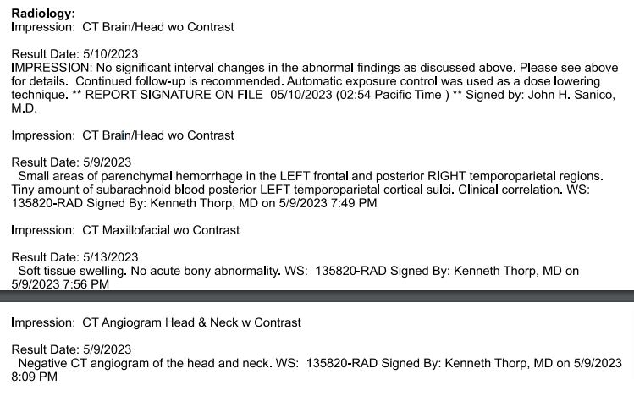  Assessment & Plan  Fall off bike with head trauma on 5/9/2023  Trauma on 5/9/2023 Traumatic SAH and IPHs  Traumatic brain injury  L-sided periorbital fracture  Dementia NOS at baseline (FAST ?)  - Non-operative management (was NOT on blood thinners)  - Decision to forgo additional aggressive interventions in favor of comfort-focused care/hospice  - Spouse Mary Ellen is activated DPoA-HC  - Trauma service placed CMO orders on 5/14/23  - Modified CMO orders to optimize comfort at end-of-life  - Hospice liaison to meet with spouse/DPoA-HC later today 5/16/23 at 1pm  - Prognosis appears months?  - Flagged chart as ME case  Multiple comorbid conditions  • Hypothyroidism, depression, osteoarthritis, murmur NOS, remote prostate cancer  Disposition  • Prognosis appears months?  • Suspect LTC + home hospice more appropriate than inpatient hospice facility at this time  • Await hospice liaison discussion with spouse  Palliative Performance (PPS) at time of consult: 60% Reduced ambulation; Unable to do hobby/housework, significant disease; Occasional assistance necessary for self care; Normal or reduced intake; Level of consciousness is full or confusion  Hospice Information: Meets Hospice Criteria for traumatic SAH with decision to forgo further aggressive interventions + comorbid conditions  +++ ADDENDUM 1500 +++  • Informed of plan for hospital discharge tomorrow 5/17/23 morning to Burcham Hills with Sparrow home hospice services  • Completed discharge medication reconciliation and ordered rescue pack medications from respective pharmacies  • Sent AMB referral for Sparrow home hospice  • See separated documentation per A. Vashaw RN for details of hospice informed consent, etc.  Thank you for allowing us to assist in the care of this patient. Please contact Palliative Care with any additional questions.  Time: 86 minutes (total) for tasks related to encounter.  Erin M Sarzynski, MD  5/16/2023  10:13 AM
05/16/2023  11:10 am  Garrett D Smigelski, PA-C  Attestation:  Jennifer L Uitvlugt, DO | 05/16/2023 11:10 am Sparrow Trauma Daily Progress Note Garrett D  Problem List:  Principal Problem:  Mehcanical Fall while riding bicycle  Active Problems:  SAH (subarachnoid hemorrhage) (HCC)  Facial trauma  History of dementia  Left orbit fracture (HCC)  Subarachnoid hematoma with loss of consciousness, initial encounter (HCC)  Closed dislocation of left thumb  Secondary hypertension  Fall from bicycle  Major neurocognitive disorder due to traumatic brain injury (HCC)  Confusion  Interval History:  Pt states he is comfortable right now.  Continue comfort care, appreciate palliative team assistance, meeting planned for 1300 today.  Focused Physical Exam: Vitals (Range for Last 24 hrs):  Temp: [97.4 °F (36.3 °C)-98.2 °F (36.8 °C)] 97.4 °F (36.3 °C)  Pulse[67-89] 67  Resp: (128-140)/(72-80) 140/72  Physical Exam  Vitals and nursing note reviewed.  Constitutional:  General: He is not in acute distress.  Appearance: Normal appearance. He is normal weight. He is not ill-appearing or toxic-appearing. Comments: pt comfortably resting  HENT:  Right Ear: External ear normal.  Left Ear: External ear normal.  Cardiovascular:  Rate and Rhythm: Normal rate and regular rhythm.  Heart sounds: Murmur (systolic murmur present) heard.  Pulmonary:  Effort: Pulmonary effort is normal. No respiratory distress.  Breath sounds: Normal breath sounds.  Abdominal:  General: Abdomen is flat. Bowel sounds are normal.  Palpations: Abdomen is soft.  Musculoskeletal:  General: Normal range of motion.  Skin:  General: Skin is warm and dry.  Capillary Refill: Capillary refill takes less than 2 seconds.  Neurological:  Mental Status: He is alert.  GCS: GCS eye subscore is 3. GCS verbal subscore is 4. GCS motor subscore is 6  Psychiatric:  Mood and Affect: Mood normal.  Behavior: Behavior normal.  Scheduled Meds:  diclofenac sodium 2g Topical 4x Daily while awake used to reduce pain, swelling (inflammation), and joint stiffness from arthritis  glycopyrrolate 0.2 mg Intravenous Q4H muscarinic anticholinergic group  lisinopril 5 mg Daily ACE inhibitor  amLODIPine 10 mg Oral Daily Calcium channel blocker  QUEtiapine 12.5 mg Oral Nightly schizophrenia, acute manic episodes  escitalopram 10 mg Oral Nightly (SSRI) approved for the acute and maintenance treatment of major depressive disorder  levETI RAcetam 500 mg Oral BID Seizures  polyethylene glycol laxative 17 g Oral Daily laxative  Atorvastatin 40 mg Oral Daily Lipitor, cholesterol  Levothyroxine 50 mcg Oral Daily thyroid  Senna 17.2 Oral Nightly stimulant laxatives  Tiotropium (SPIRIVA RESPIMAT) 2 puff Inhalation Daily per RT bronchodilators Long-acting muscarinic antagonist medication (COPD)  dextran 70-hypromellose (PF) PRN Continuous Infusions used to relieve dry, irritated eyes  haloperidol lactate **OR** haloperidol **OR** haloperidol, PRN Continuous Infusions Haloperidol is a first-generation (typical) antipsychotic medication used widely around the world.  hyoscyamine PRN Continuous Infusions Gut antispasmodic and Anti-Tremor  prochlorperazine **OR** prochlorperazine, PRN Continuous Infusions Prochlorperazine is used to treat nervous, emotional, and mental conditions (eg, schizophrenia) and non-psychotic anxiety. It is also used to control severe nausea and vomiting. This medicine should not be used to treat behavioral problems in older adult patients who have dementia.  acetaminophen PRN Continuous Infusions  Comorbidities identified by EMR data:  Thrombocytopenia: The patient meets criteria for a diagnosis of thrombocytopenia based on a platelet level of 149 x 10∧3/microliter or less, with evidence of monitoring (a subsequent platelet level during the same encounter).  Assessment/Plan:  Benzodiazepines: no  IV opiates: no  SAH  • Neurosurgery  o Repeat head stable  o OK to start Lovenox for DVT ppx, though no blood thinners for 2 weeks  o Outpatient follow-up as needed  Dementia with behavioral disturbance  - Neuropsychology  o Does not demonstrate the cognitive capacity to make informed medical decisions (Patient's wife, Mary Ellen, activated DPOA)  - Trial Seroquel 12.5 nightly (started 5/12/23) (QUEtiapine)  SBP > 150 or <90  Lactate >2.0: no  Supplemental oxygen: no. Encourage IS.  Electrolytes abnormal (NA+, K+, C02-): no  IV fluids: no  Oral nutrition: yes, House  Last bowel movement: 5/15  Smoothlax and Pericolace daily.  Urine output< 720 ml/24 h: no  Foley: no.  qSOFA:  GCS ≤ 13: no  RR≥ 22: no  BP systolic ≤ 100: no  Total score: 0  Antibiotics: none  DVT prophylaxis: n/a, pt is comfort care  Last dose: 5/14  Left orbital wall fracture  • Non-operative management  PT/OT: LTC/memory care facility.  Pt does not qualify for skilled OT/PT intervention due to major neurocognitive disorder. He will not qualify for subacute rehabilitation facility.  Estimated discharge date and location; 5/16 hospice, continue comfort care, awaiting palliative team recs and likely hospice placement  Garrett D Smigelski, PA-C  5/16/2023, 11: 11 AM  Trauma Team Pager: 226-3350  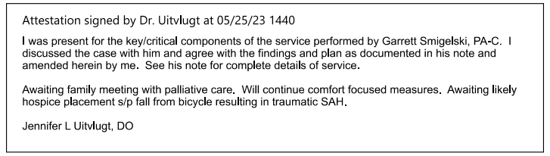
05/16/2023  1:06 pm | 05/16/2023 01:06 pm Hospice Informed Consent  Patient’s Name: Robert Forbes Cromwell  Location of Informed Consent: Done at bedside with patient and his spouse Mary Ellen  Admission to: home hospice  Address where patient receiving care: Patient is currently at SMH with a plan to transfer to Burcham hills assisted living memory care unit with sparrow hospice support  Primary Caregiver: DENNIS PERRY, MD  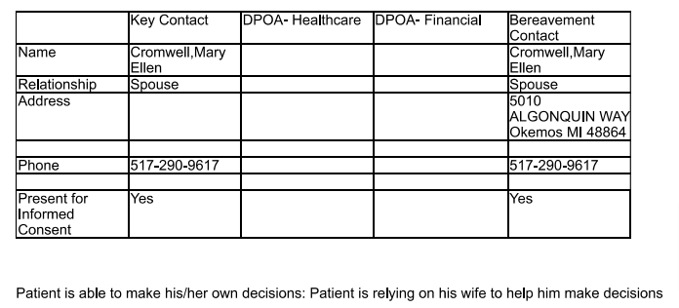  Patient is able to make his/her own decisions: Patient is relying on his wife to help him make decisions  Interpreting/translation services needed? No  Hospice philosophy of care discussed: Yes  Care Options discussed (home hospice vs. In-pt care): Yes  Reason for selecting In-Patient care/Hospice: Patient’s spouse is unable to provide 24 hour care that is necessary  Four levels of care explained: Yes  Review Advance Directives:  @[FLOW400000@  Does the patient/responsible party have a preference for cardiopulmonary resuscitation? Yes and discussion occurred  Does the patient/responsible party have a preference regarding hospitalization? Yes and discussion occurred  Does the patient/responsible party have a preference for life sustaining treatments other than CPR (Advanced Directive)? Yes and discussion occurred  Code Status:DNR  Hydration and Nutrition discussed: Yes  Hospice Team, IDT members and services, bereavement services explained: Yes  Primary Insurance: MEDICARE  Is patient a U.S. Military veteran? Did not discuss at time of visit  Does patient have Room and Board coverage? No  Patient/family responsible for services not covered by insurance: Yes  Discussed transportation not covered by hospice benefit: Yes  Medication coverage and formulary discussed: Yes  Equipment discussed: Yes  Informed of Financial Contract (Hospice House): NA  Patient/family/caregiver verbalize understanding/expectations of Hospice Care: Yes  Patient/family agree on need for hospice care: Yes  Does patient have special care needs?  Yes If yes, indicate: dementia/delirium and falls  Hospice is able to provide services to address these needs: Yes  Are there other issues that could impact the course of hospice care? No (Ex: family struggling with DNR, family and DPOA disagree, family psycho-social issues, anger, etc)  Which physician does patient/family want to manage the patient's hospice care?  patient's physician, hospice physician if Dr. Perry declines to manage  Physician's name: Dennis Perry Phone#: 517-975-9475  Notified: Dr. Office closed at time of call, unable to leave message. Will contact tomorrow  By: Abigail Vashaw, RN  (Physician must be contacted on same business day that Informed Consent completed)  Physician agrees to follow? Awaiting clarification  Do patient/family wish another physician to be notified of hospice admission? No  Narrative/Additional Comments: Explanation of hospice benefit provided to patient's wife Mary Ellen at bedside. She verbalized understanding and is in agreement that goals of care are aligned with hospice philosophy. Patient pleasantly confused throughout visit, engaging in conversation but making nonsensical statements. Mary Ellen is working with Burcham hills assisted living memory care unit for placement, they are expected to accept patient in the next couple days. Did not discuss final arrangements at time of visit.  Patient/Family's statement of goals of care: Comfort care only desired at this time. Wife expressed she is considering hiring therapists privately for patient to helping with mobility. No further aggressive or invasive treatments desired at this time.  Plan/Next Steps: Equipment ordered for delivery to facility: Hospital bed with 1 /2 rails, walker, wheelchair and bedside commode. Home medications ordered for delivery to facility through facility pharmacy. Rescue pack medications ordered for spouse to pick up from sparrow pharmacy plus 7. PSS to set up transport once facility confirms day they are able to accept patient.  Abigail V, RN  5/16/2023  1 :06 PM
05/16/23 4:10 pm | 05/16/2023 04:10 pm Progress Notes by Virginia  CHAPLAIN NOTE Chaplain-initiated visit after noting pt listed in Epic as comfort care. Routine pastoral care consult was not included with comfort care order set.  Assessment  Mr Cromwell reports doing well, enjoying TV. TV is muted; he declines to have sound turned on for it. No immediate needs expressed.  Desired Contributing Outcomes  Experiencing supportive presence  Interventions Brief supportive dialogue.  Progress/Plans  Outcome largely achieved. May follow up if time allows, probably in 1-2 days. Emotional/spiritual support also available on request (see below).  Virginia Schiefelbein, staff chaplain
05/16/2023  9:22 pm  Alaina Q Miner, RN | 05/16/2023 09:22 pm Plan of Care by Alaina Q Miner, RN  Problem: General and/or Acute Pain  Goal: Pain will be safely and adequately managed throughout hospitalization  Description: Please see associated flowsheet rows for the assessment.  Recent Flowsheet Documentation  Taken 5/16/2023 2011 by Alaina Q Miner, RN  Ability to Self-Report: Able to self-report  Problem: Risk for healthcare acquired conditions Goal: Minimize the risk for acquiring healthcare acquired conditions throughout hospitalization  Intervention: Hospital Acquired Pneumonia Interventions  Recent Flowsheet Documentation  Taken 5/16/2023 2011 by Alaina Q Miner, RN  Head of Bed Elevated: HOB 60  Intervention: Skin Interventions  Recent Flowsheet Documentation  Taken 5/16/2023 2011 by Alaina Q Miner, RN  Repositioning Interventions: Turns self  Head of Bed Elevated: HOB 60  Sleep Surface: Pressure redistribution mattress  Taken 5/16/2023 2007 by Alaina Q Miner, RN  Patient Position: Sitting  Problem: Risk for Violence  Goal: Risk for violence is minimized throughout hospitalization  Intervention: Risk for Violence Interventions  Description: See associated flowsheet rows and documentation as applicable.  Recent Flowsheet Documentation  Taken 5/16/2023 2011 by Alaina Q Miner, RN  Hourly Rounding: Yes  Problem: Risk for Falls  Goal: No falls during hospitalization  Description: Patient will not fall during hospitalization.  Outcome: Ongoing  Problem: Knowledge Deficit  Description: Patient requires education regarding causes and prevention of falls during hospitalization. Goal: Knowledge - personal safety  Description: Patient will verbalize understanding of fall prevention.  Outcome: Ongoing  Problem: Risk for or alteration in neurologic status Goal: Neurologic status is maintained and maximized throughout hospitalization  Outcome: Ongoing  Intervention: Neurological interventions  Description: See associated flowsheet rows and documentation as applicable.  Recent Flowsheet Documentation  Taken 5/16/2023 2011 by Alaina Q Miner, RN  Precautions: Fall risk  Problem: Risk for or alteration in psychosocial status and ineffective coping  Goal: Psychosocial status and coping are supported and maintained throughout hospitalization  Outcome: Ongoing  Intervention: Psychosocial Interventions  Description: See associated flowsheet rows and documentation as applicable.  Recent Flowsheet Documentation  Taken 5/16/2023 2011 by Alaina Q Miner, RN  Cognition:  • Poor safety awareness  • Short term memory loss  • Poor judgement  • Poor attention/concentration  • Unaware of deficits  Patient Behaviors:  • Confused with plan of care  • History of disruptive behavior  Problem: Risk for or alteration in musculoskeletal status  Goal: Musculoskeletal mobility status maximized or maintained throughout hospitalization  Outcome: Ongoing  Intervention: Musculoskeletal Interventions  Description: See associated flowsheet rows and documentation as applicable  See Imagining results as applicable  Recent Flowsheet Documentation  Taken 5/16/2023 2011 by Alaina Q Miner, RN  Assistive Device: Gait Belt  Problem: Risk for or alteration in cardiac status  Goal: Hemodynamic stability and cardiac status maximized or maintained throughout hospitalization Outcome: Ongoing  Problem: Risk for or alteration in genitourinary function  Goal: Genitourinary status will be maintained or optimized throughout hospitalization  Outcome: Ongoing  Intervention: Genitourinary Interventions  Description: See associated flowsheet rows and associated orders  See MARs for additional documentation
05/17/2023  8:39 am  Natalie M Fox, PA-C | 05/17/2023 08:39 am Sparrow Trauma Daily Progress Note  Natalie M Fox, PA-C  Problem List:  Principal Problem:  Mehcanical Fall while riding bicycle  Active Problems:  SAH (subarachnoid hemorrhage) (HCC)  Facial trauma  History of dementia  Left orbit fracture (HCC)  Subarachnoid hematoma with loss of consciousness, initial encounter (HCC)  Closed dislocation of left thumb  Secondary hypertension  Fall from bicycle  Major neurocognitive disorder due to traumatic brain injury (HCC)  Confusion  Encounter for palliative care  Goals of care, counseling/discussion  Interval History:  Comfort care measures only. Plan for discharge to Burcham tomorrow 5/18 with Sparrow Hospice.  Focused Physical Exam: Vitals (Range for Last 24 hrs):  Temp: [97.5 °F (36.4 °C)] 97.5 °F (36.4 °C)  Pulse: [73] 73  Resp: [20] 20  BP: (131 )/(71) 131/71  Physical Exam  Vitals and nursing note reviewed.  Constitutional:  General: He is not in acute distress.  Appearance: Normal appearance. He is normal weight. He is not ill-appearing or toxic-appearing. Comments: Resting comfortably in bed eating blueberry pancakes and sausage  Wife and daughter present at bedside  HENT:  Right Ear: External ear normal.  Left Ear: External ear normal.  Cardiovascular:  Rate and Rhythm: Normal rate and regular rhythm.  Heart sounds: Murmur (systolic murmur present) heard.  Pulmonary:  Effort: Pulmonary effort is normal. No respiratory distress.  Breath sounds: Normal breath sounds.  Abdominal:  General: Abdomen is flat. Bowel sounds are normal.  Palpations: Abdomen is soft.  Musculoskeletal:  General: Normal range of motion.  Skin:  General: Skin is warm and dry.  Capillary Refill: Capillary refill takes less than 2 seconds.  Neurological:  Mental Status: He is alert.  GCS: GCS eye subscore is 3. GCS verbal subscore is 4. GCS motor subscore is 6  Psychiatric:  Mood and Affect: Mood normal.  Behavior: Behavior normal.  Scheduled Meds:  diclofenac sodium 2g Topical 4x Daily while awake used to reduce pain, swelling (inflammation), and joint stiffness from arthritis  glycopyrrolate 0.2 mg Intravenous Q4H muscarinic anticholinergic group  lisinopril 5 mg Daily ACE inhibitor  amLODIPine 10 mg Oral Daily Calcium channel blocker  QUEtiapine 12.5 mg Oral Nightly schizophrenia, acute manic episodes  escitalopram 10 mg Oral Nightly (SSRI) approved for the acute and maintenance treatment of major depressive disorder  levETI RAcetam 500 mg Oral BID Seizures  polyethylene glycol laxative 17 g Oral Daily laxative  Atorvastatin 40 mg Oral Daily Lipitor, cholesterol  Levothyroxine 50 mcg Oral Daily thyroid  Senna 17.2 Oral Nightly stimulant laxatives  Tiotropium (SPIRIVA RESPIMAT) 2 puff Inhalation Daily per RT bronchodilators Long-acting muscarinic antagonist medication (COPD)  dextran 70-hypromellose (PF) PRN Continuous Infusions used to relieve dry, irritated eyes  haloperidol lactate **OR** haloperidol **OR** haloperidol, PRN Continuous Infusions Haloperidol is a first-generation (typical) antipsychotic medication used widely around the world.  hyoscyamine PRN Continuous Infusions Gut antispasmodic and Anti-Tremor  prochlorperazine **OR** prochlorperazine, PRN Continuous Infusions Prochlorperazine is used to treat nervous, emotional, and mental conditions (eg, schizophrenia) and non-psychotic anxiety. It is also used to control severe nausea and vomiting. This medicine should not be used to treat behavioral problems in older adult patients who have dementia.  acetaminophen PRN Continuous Infusions  Comorbidities identified by EMR data:  Thrombocytopenia: The patient meets criteria for a diagnosis of thrombocytopenia based on a platelet level of 149 x 10∧3/microliter or less, with evidence of monitoring (a subsequent platelet level during the same encounter).  Assessment/Plan:  Benzodiazepines: no  IV opiates: no  Comfort care measures only  Palliative care following  SAH  • Neurosurgery  o Repeat head stable  o OK to start Lovenox for DVT ppx, though no blood thinners for 2 weeks  o Outpatient follow-up as needed  Dementia with behavioral disturbance  - Neuropsychology  o Does not demonstrate the cognitive capacity to make informed medical decisions (Patient's wife, Mary Ellen, activated DPOA)  - Trial Seroquel 12.5 nightly (started 5/12/23) (QUEtiapine)  SBP > 150 or <90  Lactate >2.0: no  Supplemental oxygen: no. Encourage IS.  Electrolytes abnormal (NA+, K+, C02-): no  IV fluids: no  Oral nutrition: yes, House  Last bowel movement: 5/16  Smoothlax and Pericolace daily.  Urine output< 720 ml/24 h: no  Foley: no.  qSOFA:  GCS ≤ 13: no  RR≥ 22: no  BP systolic ≤ 100: no  Total score: 0  Antibiotics: none  DVT prophylaxis: n/a, pt is comfort care  Last dose: 5/14  Left orbital wall fracture  • Non-operative management  PT/OT: LTC/memory care facility.  Pt does not qualify for skilled OT/PT intervention due to major neurocognitive disorder. He will not qualify for subacute rehabilitation facility.  Estimated discharge date and location; Plan for discharge to Burcham tomorrow 5/18 with Sparrow Hospice.  Natalie M Fox, PA-C  5/17/2023, 4:11 PM  Trauma Team Pager: 226-3350
05/17/2023  2:28 pm  Erin M Sarzynski, MD | 05/17/2023 02:28 pm Palliative Care Progress Note  Subjective :  Symptoms: Stable  Activity Level: Impaired due to weakness  Pain: He reports no pain  Interval History: denies pain, dyspnea, or other concerns, patient and spouse Mary Ellen meeting with Mallory from Burcham Hills during encounter – plan for discharge to Burcham tomorrow 5/18 morning with Sparrow home hospice.  Vitals:  Patient Vitals for the past 8 hrs:  05/17/23 0902 BP 131/71 Temp 97.5 F Pulse 73 Resp 20 SpO2 94%  Objective:  General Appearance: Comfortable, ill-appearing and in no acute distress (sitting up in bed unassisted, answers questions with brief responses).  Vital signs: (most recent): above  HEENT: (L-scalp abrasion and extensive L-periobital ecchymosis)  Lungs: Normal effort and normal respiratory rate. (Appears comfortable on room air)  Neurological: Patient is alert. (Poor ST memory, limited insight re: illness severity.) (BECAUSE HE IS NOT SICK)  Skin: There is ecchymosis. (L-knee abrasion with occlusive dressing intact)  Scheduled Meds:  diclofenac sodium 2g Topical 4x Daily while awake used to reduce pain, swelling (inflammation), and joint stiffness from arthritis  glycopyrrolate 0.2 mg Intravenous Q4H muscarinic anticholinergic group  lisinopril 5 mg Daily ACE inhibitor  amLODIPine 10 mg Oral Daily Calcium channel blocker  QUEtiapine 12.5 mg Oral Nightly schizophrenia, acute manic episodes  escitalopram 10 mg Oral Nightly (SSRI) approved for the acute and maintenance treatment of major depressive disorder  levETI RAcetam 500 mg Oral BID Seizures  polyethylene glycol laxative 17 g Oral Daily laxative  Atorvastatin 40 mg Oral Daily Lipitor, cholesterol  Levothyroxine 50 mcg Oral Daily thyroid  Senna 17.2 Oral Nightly stimulant laxatives  Tiotropium (SPIRIVA RESPIMAT) 2 puff Inhalation Daily per RT bronchodilators Long-acting muscarinic antagonist medication (COPD)  dextran 70-hypromellose (PF) PRN Continuous Infusions used to relieve dry, irritated eyes  haloperidol lactate **OR** haloperidol **OR** haloperidol, PRN Continuous Infusions Haloperidol is a first-generation (typical) antipsychotic medication used widely around the world.  hyoscyamine PRN Continuous Infusions Gut antispasmodic and Anti-Tremor  prochlorperazine **OR** prochlorperazine, PRN Continuous Infusions Prochlorperazine is used to treat nervous, emotional, and mental conditions (eg, schizophrenia) and non-psychotic anxiety. It is also used to control severe nausea and vomiting. This medicine should not be used to treat behavioral problems in older adult patients who have dementia.  acetaminophen PRN Continuous Infusions  Assessment & Plan  Fall off bike with head trauma on 5/9/2023  Traumatic SAH and IPHs  Traumatic brain injury  L-sided periorbital fracture  Dementia NOS at baseline (FAST ?)  - Non-operative management (was NOT on blood thinners)  - Decision to forgo additional aggressive interventions in favor of comfort-focused care/hospice  - Spouse Mary Ellen is activated DPoA-HC  - Trauma service placed CMO orders on 5/14/23  - Modified CMO orders to optimize comfort at end-of-life  - Prognosis appears months?  - Plan for hospital discharge to Burcham Hills tomorrow 5/18/23 with Sparrow Hospice  - Flagged chart as ME case  Multiple comorbid conditions  • Hypothyroidism, depression, osteoarthritis, murmur NOS, remote prostate cancer  Disposition  • Burcham Hills tomorrow 5/18/23 with Sparrow Hospice  • Completed med rec I ordered rescue pack yesterday  Discussed with: hospice liaison Abigail RN, patient, spouse Mary Ellen and Mallory from Burcham Hills (at bedside)  Erin M Sarzynski, MD  5/17/2023  2:28 PM
5/18/2023  8:37 am  Natalie M Fox, PA-C | 05/18/2023 08:37 am Trauma Services Discharge Summary  Date of Discharge: 05/18/23  Admitting Physician: Lynn Munoz, MD  Discharging Physician: Jennifer Uitvlugt, DM  Admission Diagnoses:  SAH (subarachnoid hemorrhage) (HCC) [160.9]  Fall [W19.XXXA]  Subarachnoid hematoma with loss of consciousness, initial encounter (HCC) [S06.6X9A]  Discharge Diagnoses:  Principal Problem: Mechanical Fall while riding bicycle  Active Problems:  - SAH (subarachnoid hemorrhage) (HCC)  - Facial trauma  - History of dementia  - Left orbit fracture (HCC)  - Subarachnoid hematoma with loss of consciousness, initial encounter (HCC)  - Closed dislocation of left thumb  - Secondary hypertension  - Fall from bicycle  - Major neurocognitive disorder due to traumatic brain injury (HCC)  - Confusion  - Encounter for palliative care  - Goals of care, counseling/discussion  Indication for Admission:  Robert Forbes Cromwell is 89 y.o. male that initially presented to Mclaren ED after a fall from his bike. CT brain revealed a left SAH with left orbital and frontal bone fractures. He was transferred to SMH for further neurosurgical evaluation.  Hospital Course:  Robert Forbes Cromwell was admitted to the Trauma service.  Neurosurgery was consulted for the left SAH. Repeat head CT showed small areas of IPH in the left frontal and posterior right temporoparietal regions with a tiny left SAH. Repeat head imaging the following AM was stable. Neurosurgery recommended no blood thinners for 2 weeks. OK for Lovenox for DVT ppx. Activity as tolerated with assistance. No neurosurgical intervention warranted at this time. Outpatient follow-up as needed.  Patient with traumatic brain injury in setting of underlying major neurocognitive disorder due to probable Alzheimer's disease. Patient was evaluated by neuropsychology on 5/11, patient does not demonstrate the cognitive capacity to make informed medical decisions. Patient's wife, Mary Ellen Cromwell, was activated as patient's DPOA.  Palliative care was consulted, and decision was made to forgo additional aggressive interventions in favor of comfort-focused care/hospice. Comfort care measures only were placed on 5/14.  Discharged to Burcham Hills for long-term care with Sparrow home hospice services on 5/18.  The patient is tolerating a diet. Pain is well controlled with oral medications. Medically stable for discharge today.  Discharge Condition: Good  Physical Exam: BP 119/73 (BP Location: Left arm, Patient Position: Sitting) I Pulse 79 I Temp 97.1 °F (36.2 °C) (Oral) I Resp 17 I Ht 68" (172.7 cm) I Wt 173 lb 4.5 oz (78.6 kg) I Sp02 95% I BMI 26.35 kg/m2  Physical Exam  Vitals and nursing note reviewed.  Constitutional:  Appearance: Normal appearance.  Comments: Resting comfortably in bed in no acute distress  HENT:  Head: Normocephalic and atraumatic.  Mouth/Throat:  Mouth: Mucous membranes are moist.  Pharynx: Oropharynx is clear .  Eyes:  Extraocular Movements: Extraocular movements intact.  Pupils: Pupils are equal, round, and reactive to light.  Cardiovascular:  Rate and Rhythm: Normal rate and regular rhythm.  Pulses: Normal pulses.  Heart sounds: Normal heart sounds.  Pulmonary:  Effort: Pulmonary effort is normal. No respiratory distress.  Breath sounds: Normal breath sounds.  Comments: On room air  Abdominal:  General: Abdomen is flat.  Palpations: Abdomen is soft.  Tenderness: There is no abdominal tenderness.  Musculoskeletal:  General: Normal range of motion.  Cervical back: Normal range of motion and neck supple.  Skin:  General: Skin is warm and dry.  Capillary Refill: Capillary refill takes less than 2 seconds.  Neurological:  General: No focal deficit present.  Mental Status: He is alert. He is confused.  GCS: GCS eye subscore is 4. GCS verbal subscore is 4. GCS motor subscore is 6.  Psychiatric:  Mood and Affect: Mood normal.  Behavior: Behavior normal.  Disposition:  Skilled nursing facility  I am prescribing a controlled substance medication in a quantity that DOES NOT exceed a 3-day supply. Obtaining and reviewing a MAPS report is not required by law.  A controlled substance is a drug or other substance that the United States Drug Enforcement  Administration has identified as having a potential for abuse. My provider shared the following:  a. The risks of substance use disorder and overdose associated with the controlled substance containing an opioid.  b. Individuals with mental illness and substance use disorders may have an increased risk of addiction to a controlled substance.  c. Mixing opioids with benzodiazepines, alcohol, muscle relaxers, or any other drug that may depress the central nervous system can cause serious health risks, including death or disability.  d. For a female who is pregnant or is of reproductive age, the heightened risk of short and long-term effects of opioids, including but not limited to neonatal abstinence syndrome.  e. Any other information necessary for patients to use the drug safely and effectively as found in the patient counseling information section of the labeling for the controlled substance.  f. Safe disposal of opioids has shown to reduce injury and death in family members. Proper disposal of expired, unused or unwanted controlled substances may be done through community take-back programs, local pharmacies, or local law enforcement agencies. Information on where to return your prescription drugs can be found at: http://www.michigan.gov/deqdrugdisposal  g. It is a felony to illegally deliver, distribute, or share a controlled substance without a prescription properly issued by a licensed health care prescriber. D  Diet: Regular Diet (House/General)  Natalie M Fox, PA-C  5/18/2023,  11 :24 AM  CC: DENNIS PERRY, MD
05/18/2023  9:45 am  Rochelle R Smith, RN | 05/18/2023 09:45 am Patient Support Services Case Manager Discharge Note  Discharge arranged to Hospice Facility Burcham Hills Memory Care Assisted Living.  Patient to transport to Facility via MMR Ambulance  Schedule pick up time is 11:30 .  Discussed with Natalie Fox PA trauma, bedside RN, Abigail RN Hospice RN, Kyle Buckholz Burcham.  Facility: Burcham Hills Memory Care AL Phone  Hospice Agency: Sparrow Home Hospice Phone  Hospice Liaison: Abigail  For discharge to HOSPICE FACILITY, patient will need:  PHYSICIAN:  Discharge orders  Discharge Summary  Home Hospice Order  Order Comfort Medications  RN:  Call Report to:  DNR/Comfort orders on packet transport  Add to packet:  Discharge Summary  After Visit Summary  Rochelle R Smith, RN  5/18/2023  9:45 AM
05/18/2023  10:00 am | 05/18/2023 10:00 am Informed consent completed with Abigial in hospital Dr. Perry agrees to follow.

